`
SENIOR FIVE TERM 3 MATHEMATICS LESSON NOTES 2026
TOPIC 1/4: Series
Competency: The learner applies principles and techniques of series and binomial expansions to understand and solve mathematical and scientific problems in the real world.

Contents
Mathematical Series ..................................................................................................................................... 3
Arithmetic progression (A.P) ..................................................................................................................... 3
The sum of the first n terms of an A.P ...................................................................................................... 4
Geometric progression (G.P) .................................................................................................................... 7
Application of Arithmetic progression ...................................................................................................... 7
- Finance and Savings ...................................................................................................................... 7
- Population Growth (Linear) .............................................................................................................. 8
- Sports and Competitions ................................................................................................................... 8
- Architecture and Construction .......................................................................................................... 8
- Science and Nature ........................................................................................................................... 8
- Education .......................................................................................................................................... 8
The geometric mean (G.M) ....................................................................................................................... 8
Mixed terms of A.P and G.P .................................................................................................................... 11
Sum to infinity of a G.P ........................................................................................................................... 12
Application of A.Ps and G.Ps to interest rates ........................................................................................ 14
Application of Geometrical progression ................................................................................................. 15 1: Finance & Economics ...................................................................................................................... 15
- Population Growth .......................................................................................................................... 16
- Physics & Engineering ..................................................................................................................... 16
- Computer Science ........................................................................................................................... 16
- Architecture & Design ..................................................................................................................... 16
- Daily Life .......................................................................................................................................... 16
Proof by induction ................................................................................................................................... 16
Binomial theorem ................................................................................................................................... 19
The binomial theorem for positive integral index .............................................................................. 21
Particular terms of binomial expansion .............................................................................................. 22
Binomial expansion of terms with fractional or negative powers ...................................................... 23

Mathematical Series
Introductions
Numbers arranged in a definite order a sequence. Each number in the sequence is derived from a particular rule.
The terms below are examples of sequences
- 1, 3, 5, 7, 9 ….. is a sequence of odd numbers
- 2, 3, 5, 7, 11 … is a sequence of prime number
- 4, 16, 64 …. is a sequence formed by multiplying the proceding number by 4 to give the next number
Series are categorized into two:
- Arithmetic progression (A.P)
- Geometric progression

Arithmetic progression (A.P)
This is a series in which each term is obtained from the preceding one by addition or subtraction of a constant quantity.
The series 1 + 3 + 5 + 7 + 9 ….. is an A.P
Note the following in an A.P
- The first term of an A.P is denoted a. the first letter of the English alphabet
- There is a common difference d. in the progression, a = 1 and d = 2.
- Given the first term, a and the common difference, d 1st term = a
2nd term = a + d 3rd term = a + 2d
n^{th} term (U_{n}) = a + (n – 1)d

Example 1
Find the 30th term of a series that has an n^{th}
term given by 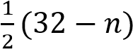
Solution
U_{n} 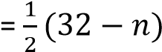
U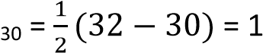

Example 2
The first term of an arithmetic progression (A.P) is 73 and the 9th term is 25. Determine the common difference Solution
U_{n} = a + (n – 1)d
25 = 73 + (9 – 1)d 25 = 73 + 8d d = -6
Example 3
The 3rd, 5th and 8th terms of A.P are 3n + 8, n + 34, and n³ + 15 respectively. Find the value of n and hence the common difference of the A.P Solution a + 2d = 3n + 8 ……………… (i) a + 4d = n + 24 ………………(ii) a + 7d = n³ + 15 …………….(iii)
Eqn. (ii) – eqn. (i) 2d = -2n + 16 d = -n + 8…………………… (iv)
eqn. (iii) – eqn. (i)
5d = n³ – 3n + 7 ………………… (v)
Substituting eqn. (iv) into eqn. (v) 5(-n + 8) = n³ – 3n + 7 n³ + 2n – 33 = 0
By factorizing the equation
(n- 3)(n² + 3n + 11) = 0 Either n – 3 = 0 or n² + 3n + 11 = 0 n = 3 since n² + 3n + 11 = 0 has no real roots Substituting for n in eqn. (iv) d = -n + 8 d = -3 + 8 = 5
Hence n = 3 and the common difference is 5
Example 4
An A.P has the first term 3, common difference -2 and nth term – 15. Find n and the (n -3)^{th} term
Solution
Given, a = 3, d =-2 , U_{n} = -15

But U_{n} = a + (n – 1)d -15 = 3 + (n – 1) x ( – 2) n = 10 substitute n – 3 for n
U_{(n – 3)} = 3 + [(10 – 3) – 1](-2)
= -9
Example 5
The n^{th} term of a series is Un = a3^{n} + bn + c given that U ₁ = 4, U₂ = 13 and U₃ = 46, find the values of a, b and c. Solution By substituting for n n = 1:
3a + b + c = 4 ……………..(i) n =2 9a + 2b + c = 13 …………(ii) n = 3
27a + 3b + 2 = 46 …………(iii)
Eqn. (ii) – eqn. (i)
6a + b = 9 …………………. (iv)
Eqn.(iii) – eqn (ii)
18a + b = 33 ……………… (v)
Eqn. (v) – eqn. (iv) 12a = 24 a = 2
Substitute for a in (v) 36 + b = 33 b = -3
Hence a = 2, b = -3 and c = 1
The sum of the first n terms of an A.P
Substituting for a and b in eqn. (i) 3 x 2 – 3 + c = 4 c = 1

There are two formulas used for finding the sum of the first n terms of the A.P depending on the terms given Formula A
If the first term, a and common difference are given, then sum (S_{n}) of the first n terms is given by
S_{n} 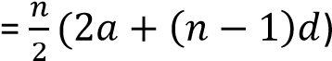
Formula B
If the first term is a and the last term is L, then sum of the first n terms (S_{n})is given by
S_{n} 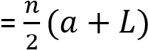
Example 6
The first term of A.P is 73 and the common difference is -6, find the number of terms that must be added to give a sum of 96
Solution
S_{n} 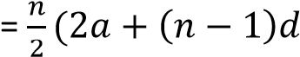
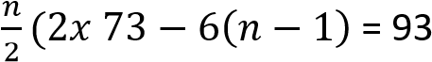
n(73 – 3(n – 1)) = 96 73n – 3n² + 3n = 96
3n² – 76n + 96 = 0
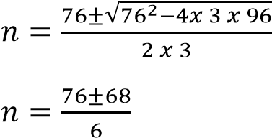
n = 24
Hence the number of terms that must be added to give a sum of 96 are 24
Example 7
The tenth term of an arithmetic progression (A.P) is 29 and the fifteenth term is 44. Find the value of the first term and the common difference. Hence find the sum of the first 30 terms
Solution
U_{n} = a + (n – 1)d U₁₀ = a + (10 – 1)d
a + 9d = 29 …………….(i)
U₁₅ = a + (15 – 1)d
a + 14d = 44 ………… (ii)
Eqn (ii) – eqn. (i) 5d = 15 d = 3 Substituting d in eqn. (i0 a + 9 x 2 = 29 a = 2
Sum of the first 30 terms
S_{n} 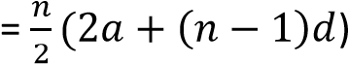
S_{n} 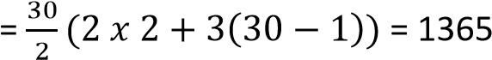
Example 8
The 5th term of an arithmetic progression (A.P) is 12 and the sum of the first 5 terms is 80. Determine the first term and common difference.
Solution
U_{n} = a + (n – 1)d [ Un= nth term, a = first term and d = common difference} U₅ = a + (5 – 1)d
a + 4d = 12 …………………………….(i)
The sum of the first n terms,
S _{n} 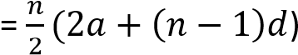
S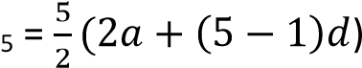
10a + 20d = 80 x 2 = 160 ………(ii)
Eqn. (ii) – 5eqn. (i) 5a = 100 a = 20
Substituting for a in eqn. (i)
20 + 4d = 12
d = -2
Hence the first term = 20 and the common difference = -2
Example 9
(a) Prove that 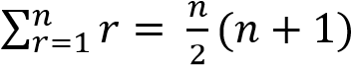

Solution
S_{n} = 1 + 2 + 3 + ….. + n
+ S_{n} = n + (n – 1) + (n – 2)+ …. + 1

2S_{n} = (n+1) + (n+1) + (n+1) + …. + (n+ 1)
2S_{n} = n(n + 1)
Sn = 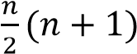
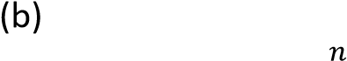Use your answer in (a) to deduce 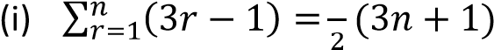
Note to deduce is to use the already existing result to work out other problems
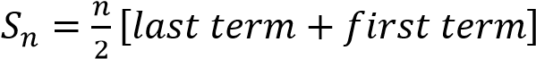
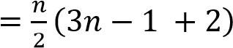
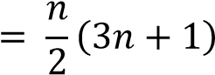
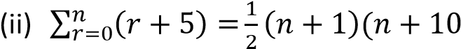
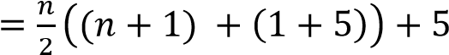
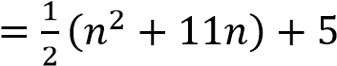
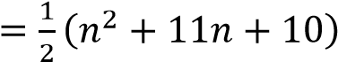
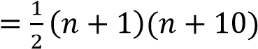

Inserting geometric means
Like for A.Ps, the terms inserted between given two values of a G.P are known as geometric means.
If n terms are inserted, then the total number of terms will be n+ 2 with the two extreme values representing the first and last terms respectively
Example 10
- Insert two geometric means between 2 and
16
Solution
1st term a = 2
4th term, ar³ = 16
2(r³) = 18
r = 2
the second term, ar = 2 x 2 = 4 the third term, ar² = 2 x 2² = 8
- Insert three geometric means between 1 and 81 a = 1
the 5th term ar⁴ = 81
1(r⁴) = 81 r = 3
the second term, ar = 1 x 3 = 3 the third term, ar² = 1 x 3² = 9 the third term, ar³ = 1 x 3³ = 27

Revision exercise 1
- Find the 5th and 8th terms of a series that has an nth term given by (-1)^{n}(2n + 1) [11, 17]
- The first term of an arithmetic progression
(A.P) is . The sixth term of th A.P is four
times the fourth term. Find the common difference of the A.P 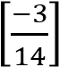
- The sum of p terms of an arithmetic progression is q and the sum of q terms is p; find the sum of p + q terms
- (a) the first four terms of an A.P are 5, 11, 17 and 23. Find the 30th term and the sum of the first 30 terms [179, 2760] (b) the second term of an A.P is 7 and the 7th term is -8. Find the first term, common difference and the sum of the first 14 terms
[ 10, -3, -133]
- (a) An A.P has the first term of 2 and common difference 5. Given that the sum of the first n terms of the progression is
119, calculate n [7]
(b) the sum of the first five terms of an A.P is . Also , five times the 7th term is the same as six times the second term. Find the first term and the common difference
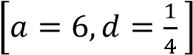
- The sum of the first n terms of the a series is n(n + 2). Find the first three terms [3,
5, 7]
- In an A.P, the 1st term is 13 and 15th term is 11. Find the common difference and sum of the first 20 terms [7, 1590]
- (a) Show that In2^{r}, r = 1, 2,3, is an arithmetic progression
    - find the sum of the first 10 terms of the progression [38.1231]
    - Determine the least value of m for which the sum of the first 2m terms exceeds 883.7 [25]
- In an arithmetic progression u ₁ + u₂ + u₃ + u₄
= 15 and u ₁₆ = -3. Find the greatest integer N such that U _{N} ≥ 0. Determine the sum of the first N terms of the progression. [ N =
14 , S ₁₄ = 136.5]

Geometric progression (G.P)
It is a series in which each term is obtained from the preceding one by multiplication or division by a constant quantity.
Observations
- The first term of G.P is also denoted, a
- The common ratio is r
- Given a and r 1st term = a
2nd term = ar
3rd term = ar²
4th term = ar³ nth term = ar^{n-1}
The sum (S_{n}) of the first n terms of G.P
The sum (S_{n}) of the first n terms of G.P is given by
S_{n} 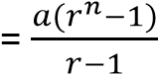 for r > 1 or
S_{n} 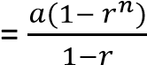 for r< 1

Application of Arithmetic progression

1. Finance and Savings
- Loan repayments: Many installment schemes follow AP, where payments increase or decrease by a fixed amount.
- Saving plans: If you save money with a fixed increment each month (e.g., sh. 100, then
sh. 120, then sh.140…), the total savings can be calculated using AP formulas.
Example 1: A person saves sh. 200 in
January, sh. 250 in February, sh.300 in
March…
This is an AP with a=200a, d=50.
Total savings in 6 months:
S
- Population Growth (Linear)
In cases where a population grows by a fixed number each year (not percentage), AP helps predict future population size.
- Sports and Competitions
Tournament scheduling: If matches increase by a fixed number each round, AP helps calculate total matches.
Athletics training: Increasing running distance by a fixed amount daily forms an AP.
- Architecture and Construction
Staircases: Steps are often designed with equal height difference, forming an AP Example A staircase has 10 steps, each 15 cm higher than the last.
Height of the 10th step: a+(n−1)d=15+(10−1)(15)=150 cm
Seating arrangements: Rows in stadiums or theaters often increase by a fixed number of seats.
- Science and Nature
Patterns in plants: Some leaf arrangements follow arithmetic sequences.
Temperature changes: If temperature rises or falls steadily, AP models the change.
- Education
Marks distribution: If marks increase by a fixed difference across assignments, AP helps in analysis.
Roll numbers: Often assigned in sequential order, forming an AP.

The geometric mean (G.M)
Suppose three numbers a, b and c are consecutive terms of GP, then, the middle term is the geometric mean.
The common ratio, r = 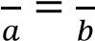
⇨ b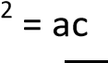
b = 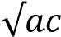, the geometric mean
Example 10
A GP has 3rd term 7 and 5th term 847. Find the possible values of the common ratio and the corresponding 4th terms
Solution
U₃ = ar² = 7
- ar² = 7 ………………..(i) U₅ = ar⁴ = 847
- ar⁴ = 847 ……………(ii)
Eqn. (ii) eqn. (i) r² = 121 r = 11 From eqn (i)
a = 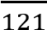
The 4th term, U₄ = ar³
If r = 11, U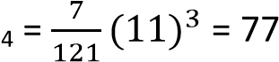
If r = -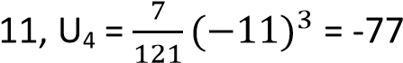
Example 11
In a G.P the 2nd term is 15 and the 5th term is 405. Find the sum of the first 8 terms
Solution
U₂ = ar = 15
- ar = 15 ……………………..(i)
U₅ = ar⁴ = -405
- ar⁴ = -405 Eqn. (ii) eqn. (i) r³ =-27 r = -3
From eqn. (i), a = -5
Since r < 1
S_{n} 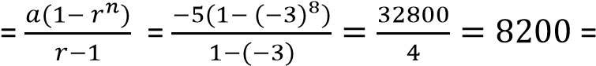
Example 12
In the geometric series u₁ + u₂ + u₃ + … u₁+ u₃ = 26 and u₃ + u₅ = 650.
Find the possible values of u₄ Solution u₁+ u₃ = 26 a + ar² = 26 a(1 + r²) = 26 ………………… (i) u₃ + u₅ = 650. ar² + ar⁴ = 650 ar²(1 + r²) = 650 ……………(ii) Eqn. (ii) eqn. (i)
r² = 25
r = 5
From eqn. (i) a(1 + 25) = 26 a = 1 u₄ = ar³
If r = 5; u₄ = a(5)³ = 125
If r = 5; u₄ = a(-5)³ = -125
Example 13
In a Geometric Progression (G.P), the difference between the fifth and the second term is 156. The difference between the seventh and the fourth is 1404 Find the possible values of the common ratio.
U₅ – U₂ = 156 ar⁴ – ar = 156 ar(r³ -1) = 156 ……………. (i)
U₇ – U₄ = 156 Ar⁶ – ar³ = 1404 ar³(r³ -1) = 156 ……………. (ii)
Eqn. (ii) eqn. (i)
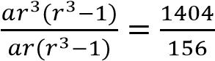
r² = 9 r = 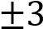
r = 3 and r = -3
Example 14
(a) The first three terms of a Geometric progression (G.P) are 4, 8 and 16. Determine the sum of the first ten terms of the G.P.
(04marks) solution
a = 4, ar = 6 4r = 8 r = 2
S_{n} 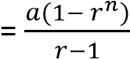

S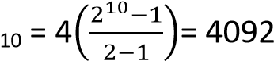

(b) An Arithmetic Progression (A.P) has a common difference of 3. A Geometric Progression (G.P) has a common ration of 2. A sequence is formed by subtracting the term of the A.P from the corresponding terms of the G.P. The third term of the sequence is 4. The sixth term of the sequence is 79. Find the first term of the
- A.P (08 marks)
- G.P (06 mars)
A.P
x, x+3, x +6, x + 9, x + 12, x+ 15, …… G.P y, 2y, 4y, 8y, 16y, 32y, …. 4y – (x + 6) = 4
4y – x = 10 ……………..(i) 32y – (x + 15) = 79
32y – x = 94………….. (ii)
Eqn. (ii) – Eqn. (i)
28y = 84, => y = 3
Substituting for y into eqn. (i) 12 – x = 10 x =2 (i) A.P, U₁ = 2 (ii) G.P, U₁ =3
Example 15
The sum of the first n terms of a geometric progression (G.P) is 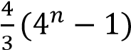. Find the n^{th} term as an integral power of 2
Solution
S_{n} 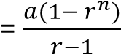
Comparing with S_{n} 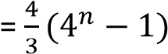
a = 4 r – 1 = 3, r = 4 The n^{th} term, U_{n} = ar^{n – 1}
= 4 x 4n-1 = 22 x 22(n-1) = 22+2n-2 = 22n
Example 16
Find three numbers in geometrical progression such that their sum is 26 and their product is 216
Solution
Let the numbers be , a and ar
Product = 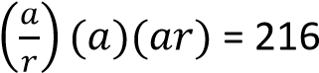
a³ = 216 = 6³ a = 6
the terms are 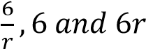
Sum of terms 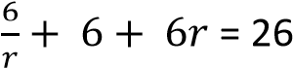
⇨ 6r² – 26r + 6 = 0 3r² – 13r + 3 = 0
(r – 3)(3r – 1) = 0
Either r – 3 = 0; r = 3 Or 3r - 1 = 0; r = When r = 3
the terms are 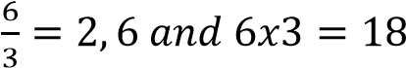
when r 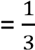
the terms are 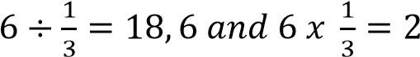
Hence the terms in their order are 2, 6, 18 or 18, 6, 2

Inserting geometric means
Like for A.Ps, the terms inserted between given two values of a G.P are known as geometric means.
If n terms are inserted, then the total number of terms will be n+ 2 with the two extreme values representing the first and last terms respectively
Example 16
- Insert two geometric means between 2 and
16
Solution
1st term a = 2
4th term, ar³ = 16
2(r³) = 18
r = 2
the second term, ar = 2 x 2 = 4 the third term, ar² = 2 x 2² = 8
- Insert three geometric means between 1 and 81 a = 1
the 5th term ar⁴ = 81
1(r⁴) = 81 r = 3
the second term, ar = 1 x 3 = 3 the third term, ar² = 1 x 3² = 9 the third term, ar³ = 1 x 3³ = 27

Mixed terms of A.P and G.P
These are problems involving both A.Ps and G.Ps. when handling we make use of their respective properties.
Example 17
A geometric progression (G.P) and an arithmetic progression (A.P) have the same first term. The sum of their first, second and third terms are 6, 10.5 and 18 respectively. Calculate the sum of their 5th terms.
Solution
Terms | G.P | A.P | Sum
1st | a | a | 2a = 6 …………………(i)
2nd | a + d | ar | a + d + ar = 10.5 ….(ii)
3rd | a + 2d | ar² | a + 2d + ar² = 18 ..(iii)

From eqn. (i): 2a = 6; a = 3
From eqn. (ii): 3 + d + 3r = 10.5 d + 3r = 7.5 ……………….. (iv) From eqn. (iii) 3 + 2d + 3r² = 18
2d + 3r² = 15 ……………..(v)
Eqn. (v) – 2eqn. (iv)
3r² – 6r = 0 3r(r -2) = 0 r -2 = 0 r = 2
Substitute for r into eqn. (iv) d + 6 = 7.5 d = 1.5
Sum of their fifth terms
= (a + 4d) + ar⁴
= (3 + 4 x 1.5) + 3 x 2⁴ = 57
Example 18
The 1st, 4thand 8th terms of A.P form a G.P. if the first term is 9, find the
- Common difference of the A.P
- Common ratio of the G.P
- Difference in sums of the first 6 terms of the progressions.
Solution
Given that a, a + 3d, a + 7d form a G.P
Substituting for a = 9, the terms are
9, 9 + 3d, 9 + 7d
For a G.P, r = 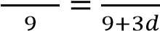
⇨ (9 + 3d)2 = 9(9 + 7d)
81 + 54d + 9d² = 81 + 63d
9d² – 9d = 0
9d(d – 1) = 0
Either d – 1 = 0; d = 1 Or d = 0
When d = 0 all terms of A.P are equal
Hence the common difference d = 1
Example 19
(a) The sum of the first m terms of a progression is m(2m + 11) (i) Show that the progression is an A.P
(ii) Determine the nth term of the progression
Solution
Given S_{m} = m(2m + 11)
First term = S₁ = 1(2 x 1 + 11) = 13
S₂ = 2(2 x 2 + 11) = 30
Second term = 30 – 13 = 17
S₃ = 3(2 x 3 + 11) = 51
Third term = 51 – 20 = 21
The progression is 13, 17, 21, ….. Hence A.P with the first term 13 and common difference, d= 4
(ii) U_{n} = S_{n} – S_{n-1}
= n(2n + 11) – (n – 1)(2(n -1) + 11)
= 9 + 4n
Example 20
- The first, second and last term of an A.P are a, b, c respectively. Prove that the sum of all
terms is 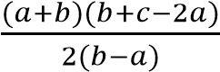
Solution
If the 1st term is a and the second term is b; the common difference, d = (b – a) Last term (nth terms c = a + (n – 1)d c = a + (n – 1)(b – 1)
i.e. n – 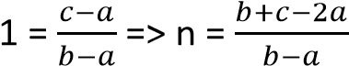 but S_{n} 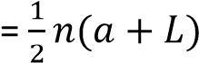
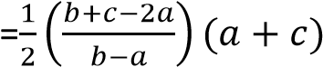
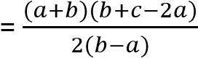

- The first, second and last terms of a GP are a and b. show that the sum of the first n
terms is 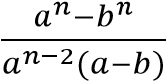
Solution
Common ratio =
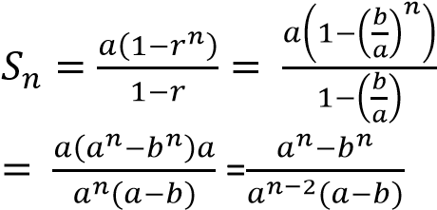

Sum to infinity of a G.P
We have seen that the sum of n terms of a G.P
for r < 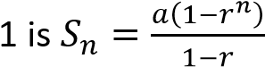
Now for -1 < n < 1 i.e. 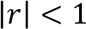, as n →, r^{n} →0
Therefore 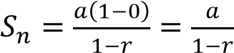
Hence the sum of a GP to infinity for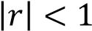 converges to 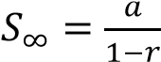 and diverges for r > 1
and r < 1
Example 21
- Calculate the sum to infinity of the following terms
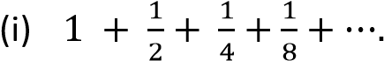
Solution a = 1 and r =
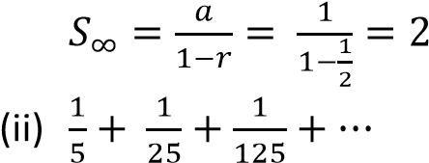
Solution a = and r =
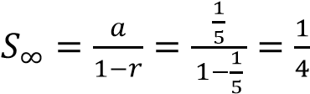
- Work out the following
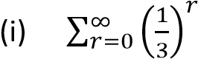
Solution
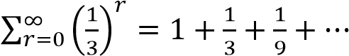
a = 1 and r =
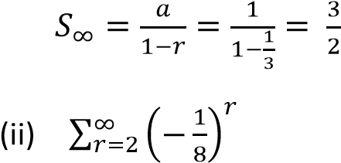
Solution
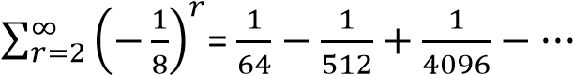
A =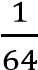 and r =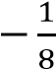
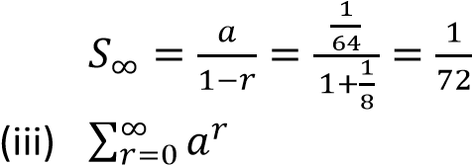
Solution a = 1 and r = a
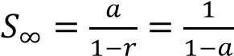

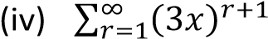
Solution
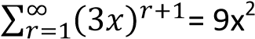+ 27x³ + 81x⁴ + …
a = 9x² and r = 3x
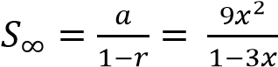
Example 22
- Express the following as fractions using approach of sum of a G.P to infinity
(i) 0. ̇
Solution
0.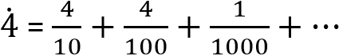
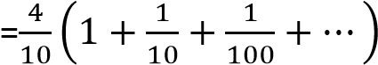
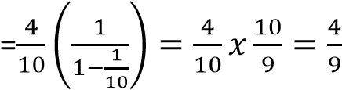

(ii) 3.1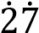
Solution
3.1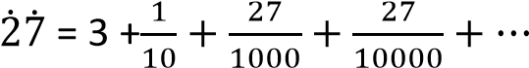
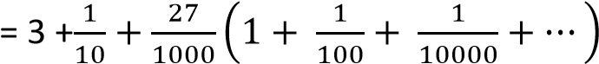
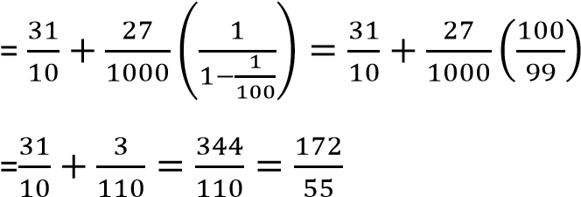
Hence 3.1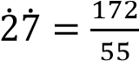
- The sum to infinity of a GP is 7 and the sum of the first two terms is . Find the common ratio and the first term of the GP with positive common ratio
Solution
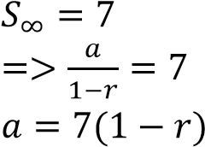 …………………….(i)
But S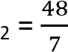
a + ar = a(1 + r) = ……………………….(ii)

substituting eqn. (i) into eqn. (ii)
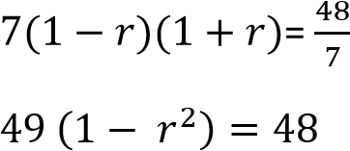
49r² = 1
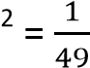
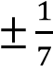
r Considering appositive ratio
r =
From eqn. (i)

a = 7(1 - 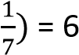

Revision exercise 2
- The common ration of a GP is -5 and the 7. What is the smallest number of terms of GP sum of the first seven terms of the 5, 10, 20 …. that can give a sum greater progression is 449. Find the first three than 500, 000 [n= 17]
_{terms.} 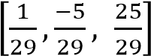 8. The first, fourth and eighth terms of
- In the geometrical series 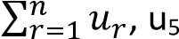 – u2 = Arithmetic progression (A.P) form a
156 and u₇ – u₄ = 1404. Find the possible  values of the common ratio and  corresponding values of u [ | geometric progression. If the first term is 9, find  (i) The common difference of A.P [ 1]
1
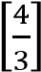
r = 3, a = 156; r = -3, a = 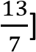 (ii) The common ratio of the G.P
- The sum of the second and third terms of a (iii) The difference in the sums of the first 6 G.P is 9. It the seventh term is eight times terms of the progressions [55.7049] the fourth term, find the 9. The second, third and ninth terms of an A.P
(a) The first term and the common ration form a G.P. find the common ratio of the
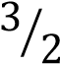
G.P [6]
[a = and r = 2]
10. (a) The sum of the first 10 terms of an AP is (b) The sum of the fourth and first term 120. The sum of the next 8 terms is 240.
^{[36]} Find the sum of the next 6 terms [264]
- Find the sum of ten terms of geometrical (b) the arithmetic mean of the a and b is series 2, -4, 8 ….. *-682] three times their geometric mean. Show
- The second and the third terms of a G.P
that

√

respectively. Find b if the sum of the first three terms of the progression is 76 | 11. The first three terms of a geometric series are 1, p, and q. Given also that 10, q and p
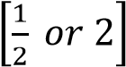
progression are 24 and 12(b + 1)
are the first three terms of an arithmetic
series. Show that 2p² – p – 10 = 0
- The sum of the 2nd and 3rd terms of a G.P is Hence find the possible values of p and q [p
12. The sum of the 3rd and 4th terms is -36.
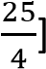
= -2 and q = 4 or p = and q = Find the 1st term and common ratio [a = 2, r = -3]

Application of A.Ps and G.Ps to interest rates
If a sum of money P is invested at a simple interest rate of r% per annum, the amount received after n years is given by A = P + I
where I = 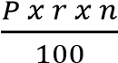
By substitution we have
A = P + 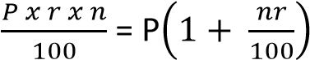 The interest for one year is 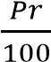, for 2 years is
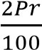, for n year = 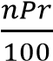. Therefore the various amounts of interest after one, two, three, etc. years form an AP
On the other hand, if the principal P is invested at compound interest rate of r% per annum, the interest being added annually, the amount after one year is 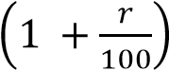 , after two years is
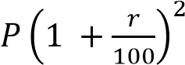, after 3 years is
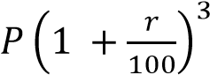 and after n years 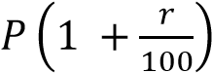
Hence the amounts after one, two, three, etc. years for a GP.
Note: if with compound interest is added half annually as much as when added yearly, but it is added twice as much. Hence amount A =
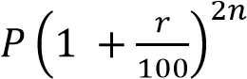
Now suppose that instead of adding the interest annually, it is the principal, P which is added annually,
Amount after 1st year = 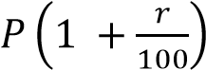
Amount after 2nd year = 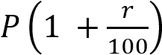
Amount after 3rd year = 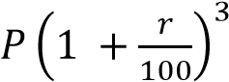
Amount after n^{th} year = 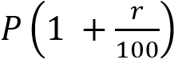
Total amount after n years

Application of Geometrical progression
1: Finance & Economics
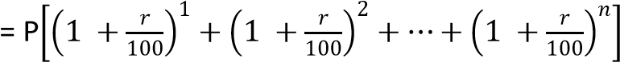
This is a G.P with:
first term = 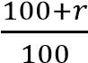= (100 + r)%
And common ratio 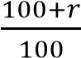= (100 + r)%
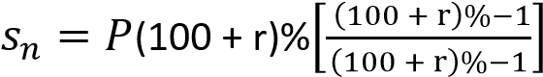
Example 23
- Find the amount at the end of ten years when 500000 shillings is invested at 5% compound interest
  - the interest being added annually Solution
    - = 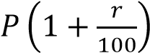
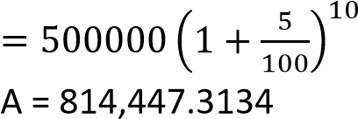
  - the interest being added twice a year Solution
    - =
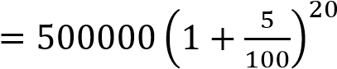
A = 1,326,648.853

- Find the amount at the end of ten years when 500000 shillings is invested at 5% simple interest
A = 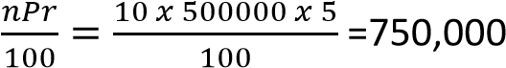

- Compound Interest: Money invested grows by a fixed percentage each period. Example: If you invest Sh.1000 at 10% interest annually, the amounts form a GP: 1000,1100,1210,1331,…1000, 1100, 1210, 1331, ……
- Depreciation of Assets: Value of a car decreasing by 20% each year follows GP.
- Population Growth
  - If a population multiplies by a fixed factor (e.g., doubling every 25 years), GP models the growth.
- Physics & Engineering
  - Radioactive Decay: The remaining mass of a substance decreases by a fixed ratio over equal time intervals.
  - Waves & Acoustics: Harmonics in sound frequencies often follow GP patterns.
- Computer Science
  - Algorithm Complexity: Recursive algorithms (like binary search or divide-and-conquer) often involve GP in their step counts.
  - Data Structures: Memory allocation sometimes grows geometrically (e.g., dynamic arrays doubling in size).
- Architecture & Design
  - Fractals: Patterns like Sierpinski triangles or geometric tiling use GP scaling.
  - Building Levels: Skyscraper window sizes or spacing sometimes follow geometric scaling.
- Daily Life
  - Phone Battery Drain/Charge: Charging often follows exponential (GP-like) growth.
  - Medicine Dosage Decay: Drug concentration in the body decreases geometrically over time.

Proof by induction
This is a mathematical technique that uses the reasoning that if a statement is true for a particular value say n = 1, then it must be true for n = 2, 3, 4, …. This involves the proof that the series on the LHS must be equal to the terms on the RHS Example 24
Prove by induction that
1 + 2 + 3 + …+ n = 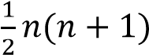
Solution
Here we need to show that the above series agrees for all values of n = 1, 2, 3 .., q and q +1 Suppose n = 1
LHS = 1 [taking only the 1st number]
RHs = 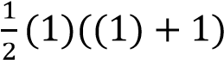= 1[substituting for n = 1]
LHS = RHS => the series hold for n = 1
Suppose n = 2
LHS = 1+ 2 = 3 [taking first 2 numbers]
RHs = 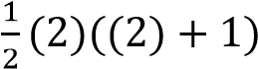= 3[substituting for n = 2]
LHS = RHS => the series hold for n = 2
Suppose n = q
1 + 2 + 3 + …+ q = 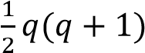
For n = q +1(i.e. adding k + 1 on both sides)
1 + 2 + 3 + …+ q + (q+1) = 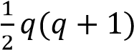+ (q + 1)
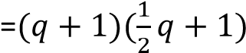
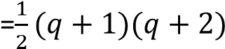
The result is true for n = q + 1, hence true for all positive values of n
Example 25
Prove by induction
(a) 1² + 2² + 3² + …. + n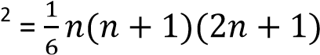
Solution
For n = 1
LHS = 1² = 1;
RHS = 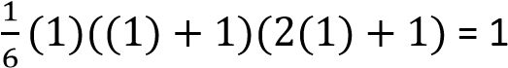
LHS = RHS => the series holds for n = 1
For n = 2
LHS = 1² + 2² = 5;
RHS = 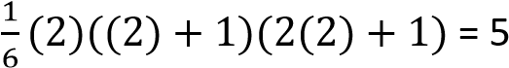
LHS = RHS => the series holds for n = 2
For n = k
1² + 2² + 3² + …. + k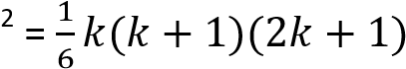
For n = k + 1
1² + 2² + 3² + …. + k² +(k+ 1)²
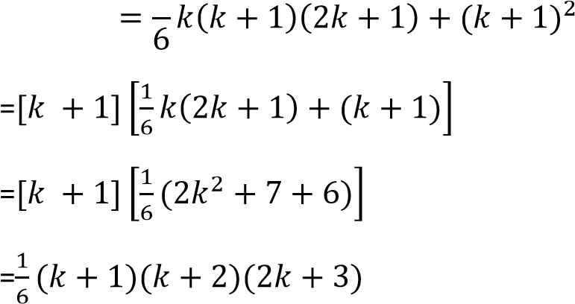
LHS = RHS => the series holds for n = k+1 hence for all positive values of n
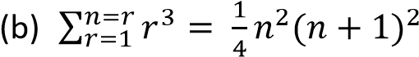
Solution
For n = 1
LHS = 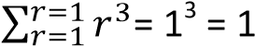
RHS =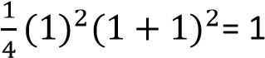
LHS = RHS => the series holds for n = 1
For n = 2
LHS = 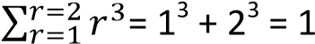
RHS =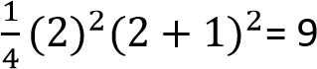
LHS = RHS => the series holds for n = 2
For n = k
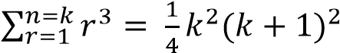
For n = k+1
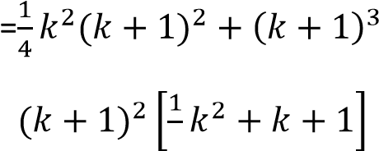
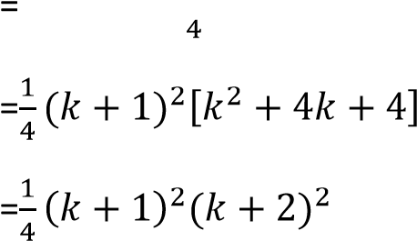
(c) p + pq + pq² +…+pq^{n-}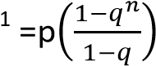
For n = 1, LHS = p
RHS =p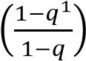= p
the identity is true for n = 1
For n = 1,
LHS = p + pq =p(1+q)
RHS =p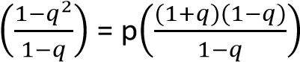=p(1+q) the identity is true for n = 2 For n = k
p + pq + pq² +…+pq^{k-}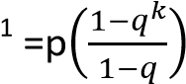
For n = k+1
p + pq + pq² +…+pq^{k-}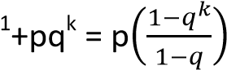+pq^{k}
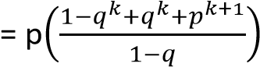

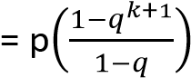 the identity is true for n = k+1, hence true for all positive values of n

Revision exercise 3

- Five millions shillings is invested each year at a rate of 15% compound interest by a certain bank.
  - Find how much he will receive at the end of ten years [116.7464m]
  - How many years will it take to accumulate to more than 50m [6]
- John opened an account in the bank and deposited200,000 shillings every month for ten months without withdrawing. Find how much money he accumulated after 10 months if the bank offered 10% compound interest per month.
[3,506,233.412]
- Peter deposited sh. 100,000 at the beginning of every year for 5 years; find how much he got at the end of the fifth year at the compound interest rate of 2% per annum. [530,812.1]
- Prove by induction
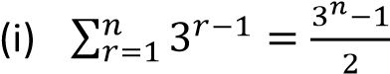
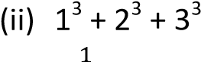+ …. + n³
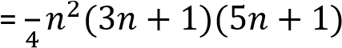
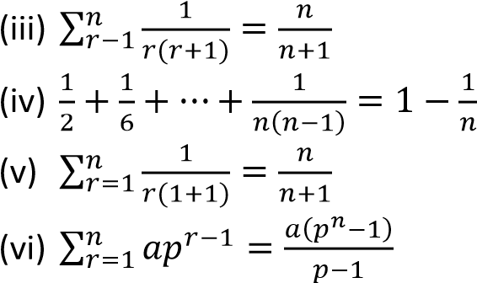
- The sum of the first n terms of a
Geometric Progression (G.P) is 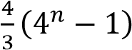.
Find its nth term as an integral power of 2
[2^{2n}]
- Prove by mathematical induction the 3^{2n} – 1 is a multiple of 8 for all positive integers n
- Use the method of induction to prove that 6n – 1is divisible by 5 for all positive integral values of n
- Prove by induction that
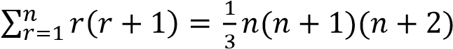
hence evaluate 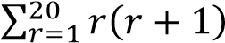

Binomial theorem
Pascal’s triangle
The Pascal’s triangle below and its further extension is used to determine the coefficients of the expansion of (p + q)^{n}
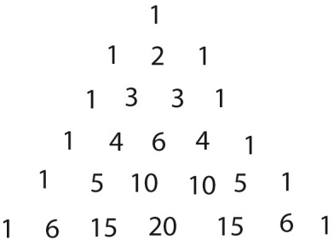
Observations
- The coefficients are symmetrical; they are the same irrespective of which side they are read from, for instance the coefficients of (p + q)⁶ are 1 6 15 20 15 6 1
- The coefficient of the 2nd term in the expansion is the index of a given expansion. E.g. in the expansion of
(p + q)⁶, the coefficient of the 2nd term is 6.
- The number of terms in the expansion exceeds the index by one, e.g. (p + q)⁴ with index 4, has 5 terms
- The index of the first term of the expansion decreases by one, from the index given till zero, whereas, the index of the second term increases by one from zero to the given index
For (p + q)³ = 1p³q⁰ + 3p²q¹ + 3p¹q² + 1p⁰q³
=p³ + 3p²q + 3pq² + q³
- The sum of indices in each term s constant and equal to the index of the expansion.
Example 1
Use Pascal’s triangle to expand (a) (p + q)⁴
The coefficients are 1 4 6 4 1
Terms are 1p⁴q⁰ + 4p³q¹ + 6p²q² + 4p¹q³ + 1q⁴ = p⁴ +4pq + 6p²q² + 4pq³ + q⁴
- (2x + 3y)³
The coefficients are 1 3 3 1
Terms are
1(2x)³(3y)⁰ + 3(2x)²(3y)¹ + 3(2x)¹(3y)² + 1(2x)⁰(3y)³
= 8x³+ 36x²y + 54xy² + 27y³
- (a + b + c)²
The terms can be grouped into two ways:
Either a and (b + c) or (a + b) and c
The coefficients are 1 2 1
Either
Terms are: 1a²(b + c)⁰ + 2a¹(b + c)¹ + 1a⁰(b + c)²
= a² + 2a(b + c) + (b + c) ²
= a² + 2ab + 2ac + b² + 2bc + c²
Or
(a + b + c)²
= 1(a + b)²c⁰ + 2(a + b)₁c¹ + 1c²
= (a + b)² + 2c(a + b) + c²
=a² + 2ab + b² + 2ac + 2bc + c²

Example 2
Expand (a + b)⁴ using Pascal’s triangle. Hence find (1.996)⁴ correct to 3 decimal places
Solution
From Pascal’s triangle the coefficients are 1 4 6 4 1
(a + b)⁴ = a⁴ + 4a³b + 6a²b² + 4ab³ + b⁴
(1.996)⁴ = (2- 0.004)⁴
Substituting a = 2 and b = -0.004
24 + 4(2)³(-0.004) + 6(2)²(-0.004)² + 4(2)(-0.004)³ + (-0.004)⁴
16 – 0.128 + 0.000384 = 15.872 (3D)
Example 3
(a) Expand (2 – 3x)⁴ using Pascal’s triangle. Hence evaluate (1.97)⁴ correct to 3 decimal places.
Solution
Coefficients: 1 4 6 4 1
(2 – 3x)⁴ = 1 (2)⁴(-3x)⁰ + 4(2)³(-3x)¹ + 6(2)²(-3x)²
+ 4(2)¹(-3x)³ + 1(2)⁰(-3x)⁴
= 16 – 96x + 216x² – 216x³ + 81x⁴
Now (1.97)⁴ = (2 – 0.03)⁴ = (2 – 3(0.01))⁴
⇨ x = 0.01
(1.97)⁴ = 16 – 96 (0.01) + 216(0.01)² - 216(0.01)³ + 81(0.01)⁴ = 15.0613848
= 15.061 (3d.p)
(b) Use Pascal’s triangle to evaluate (1.02)³ correct 5 significant figures
Solutions
(1.02)³ = (1 + 02)³
Coefficients are : 1 3 3 1
(1 + 02)³ = 1³ + 3(1)²(0.02) + 3(1)(0.02)² +
(0.02)³ = 1.061208
= 1.0612 (5 significant figures)
The idea of factorial and combination can also be used to determine the coefficients of the expansions Example 3
Expand
(a) (p + 3q)³
Solution
The coefficients are ³C₀ ³C₁ ³C₂ ³C₃
Terms are p³ p²(3q) p(3q)² (3q)³
= P³ + 9P²3q + 27pq² + 27q³  (b) (1 – x)⁴. Hence evaluate (0.99)⁴ correct to four decimal places  Solution  Coefficients are ⁴C₀ ⁴C₁ ⁴C₂ ⁴C₃ ⁴C₄ | ⁴C₃1¹(-x)³ +⁴C₄1⁰(-x)4⁰  = 1 – 4x + 6x² – 4x³ + x⁴  Now 0.99 = 1 – 0.01) = x = 0.01  (0.99)⁴
 | = 1 – 4(0.01) + 6(0.01)² – 4(0.01)³ + (0.01)⁴
Or simply 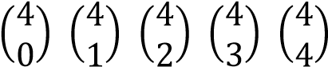 = 0.96059601
1 – x)⁴ = ⁴C₀1⁴(-x)⁰ + ⁴C₁1³(-x)¹ + ⁴C₂1²(-x)² + = 0.9606 (4d.p)

The binomial theorem for positive integral index
(p + 3q)³ = ³C₀p³ + ³C₁p²(3q) + ³C₂p(3q)² + Consider the expansion of (1 + x)⁴, the result is
(1 + x)⁴ = 1 + 4x + 6x² + 4x³ + x⁴
Observations
- The indices of x increase by 1 from term to term
- The index of the last term being the same as the power to which (1 + x) s raised
- The coefficients of the terms of expansion are 4C0 4C1 4C2 4C3 4C4
Hence the expansion of (1 + x)^{n} is
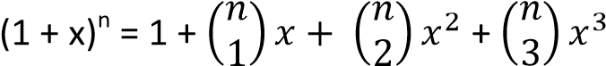+ …. x^{n} The expansion of (a + x)^{n} is
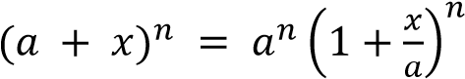
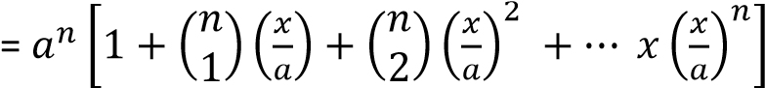
Example 4
Expand (1 + 4x)¹⁴ in ascending power of x up to and include the 4th term. Hence evaluate (1.0004)¹⁴ correct to four decimal places
Solution
(1 + 4x)¹⁴
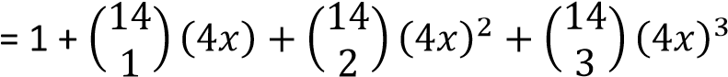
= 1 + 56x + 1456x² + 23296x³
Now (1.0004)¹⁴ = (1 + 0004)¹⁴ => x = 0.0001
(1 + 4x)¹⁴
= 1 + 56(0.0001) + 1456(0.0001) ² +
23296(0.0001) ³
= 1.005614583
= 1.0056 (4d.p)
Note the next term in the expansion is
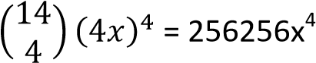
Its value = 256256(0.0001)⁴ = 2.56256 x 10⁻¹¹
Which when added to the above answer there will negligible change in value
Example 5
Expand (3 – 2x) ¹² in ascending powers of x up to and including the term x³ . Hence evaluate (2.998)¹² correct to the nearest whole number.
Solution
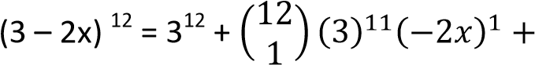
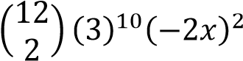+ …
= 531441 – 4251528x + 1588936x²
Now (2.998)¹² = (3 – 0.002)¹² => x = 0.001
(2.998)¹² =531441 – 4251528(0.001) +
1588936(0.001)²
= 527205.0609 =527205 (nearest whole number)

Particular terms of binomial expansion As earlier seen, the expansion of
(a + x)⁵ = a⁵x⁰ + 5a⁴x¹ + 10ax² + 10a²x³ + 5ax⁴ +
x⁵
In general if r is the power of x in the expansion (a + x)^{n}, then the U_{r+1} term of x = ^{n}C_{r}a^{n-r}x^{r}
Example 6
Find the term of x⁴ in the expression of
- (1 + x)⁹
By using U_{n+1}; term of x = ^{n}C_{r}a^{n-r}x^{r} n = 9, r = 4, a = 1
U5 = 9C419-4x4 = 9C4x4 = 126x4
- (3 + x)7 n = 7, a = 3, r = 4
U₅ = ⁷C₄3⁷⁻⁴x⁴ = ⁷C₄(3)³x⁴ = 945x⁴
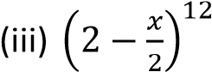
U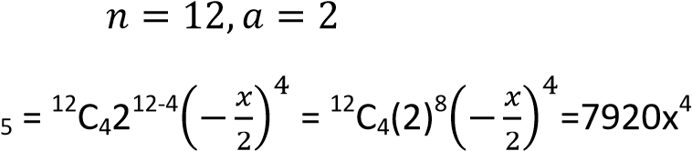
Example 7
Find the term indicated in expansion of the following expression
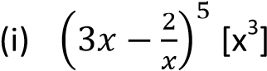
( )
( )
The term in x =
( ) ( )

The term in x³ = .⁶C₁1⁵( )
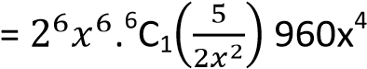
Finding terms independent of x
The term is said to be independent of x if the power of x is zero
Example 8
Find the term independent of x in the following expansion
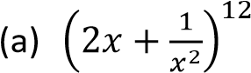
Solution
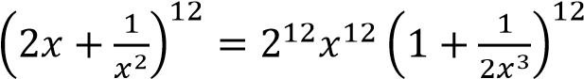
The term independent of x = 2¹²x¹² multiplied by the term in x⁻¹² in the expansion
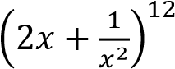
- The term independent of x
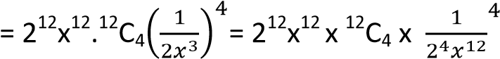
=2⁸ x 495 = 126720
Alternatively
By using Ur+1 = nCran-rxr
The term independent of x is got by equating the index of x to zero
U_{r +1} 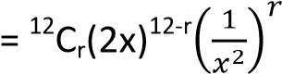
= 12Cr(2x)12-rx-2r = 12Cr. 212-r .x12-3r
Equating the x^{12-3r} = 1
- 12 – 3r = 0; r = 4
Term independent of x = ¹²C₄. 2¹²⁻⁴  =¹²C₄. 2⁸  = 126720 | = 12Cr(2x2)12-r(3r)x-r  = 12Cr. 212-r(3r)x24-3r Equating the x^{12-3r} = 1
⇨ 24 – 3r = 0
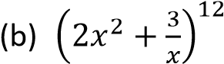
r = 8
Solution | Term independent of x = ¹²C₈. 2¹²⁻⁴.3⁸
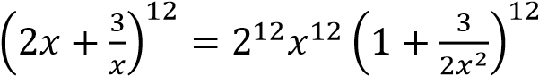 =¹²C₈. 2⁴.3⁸
Un+ r = 12C_{r}(2x2)12-r(3x-1)r = 51, 963,120

Binomial expansion of terms with fractional or negative powers
As noted earlier
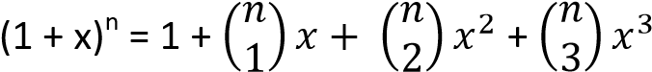+ …. x^{n}
The following is noted
- For positive integral value of n, i.e. n ≥ 1, the series above terminates at the term x^{n} and its sum is (1 + x)^{n}.
- For fractional or negative values of n, the series above does not terminate but
instead converges to (1 + x)^{n} as the limit of its sum only -1 < x< 1 or 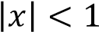
Example 9
Expand up to the term x³. Hence evaluate correct to four decimal places.
√

√

Solution
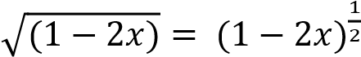
Using
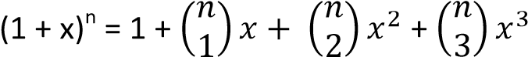+ …. x^{n}
Comparing with 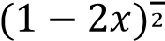 => x ≡ -2x and
n = ½
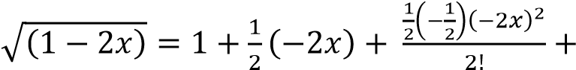
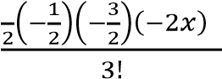
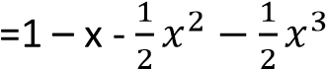
Now 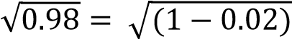
Comparing with 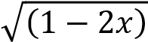; x = 0.01
Substituting
= 0.9899495
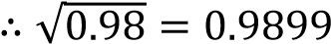 (4d.p)

Example 10
Given that x is very small that its cube and higher powers can be neglected, show that
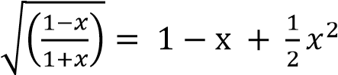
By putting x = show that 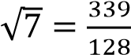
Solution
By rationalizing the denominator
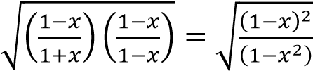
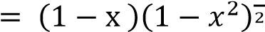
But 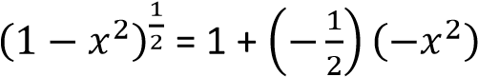+ …..
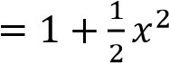
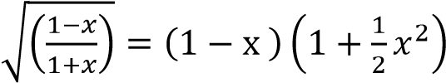
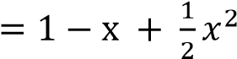
Putting x =
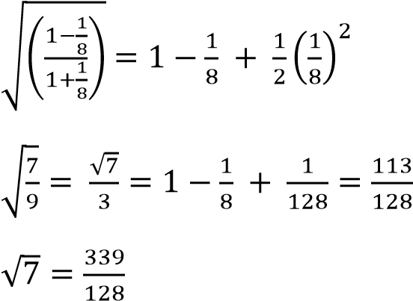
Example 11
Expand 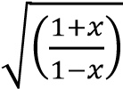 up to the term x³
Use your expansion to evaluate correct to 3 decimal places taking x = 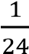.
√

Solution
By rationalizing the denominator
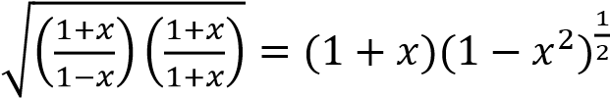
But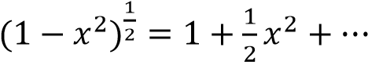
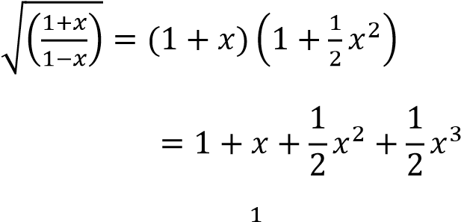
Hence putting x = 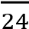
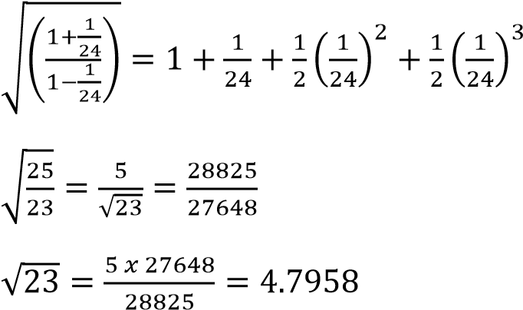
√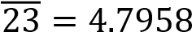 (4d.p)
Example 12
Use the binomial theorem to expand 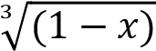 up to x³ . Use your expansion to
evaluate correct to four decimal places
√

Solution
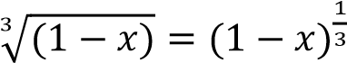
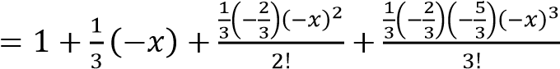+ …
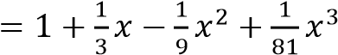
Hence 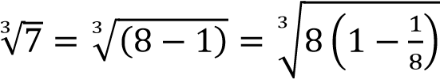
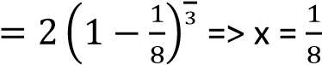
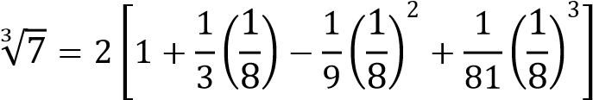
=1.9130(4d.p)
Example 13
Write down the expansion of in
√

ascending powers of x as far as the term x⁴. Use your expansion to find correct to four significant figures.
√

Solution
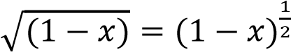
For binomial expansion
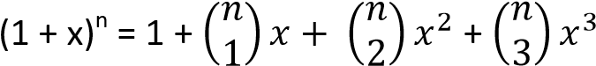+ …. x^{n}
Comparing 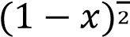 with(1 + x)^{n}
n = and x = -x

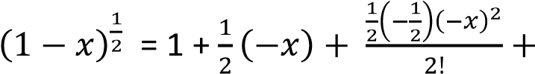
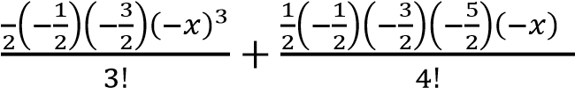
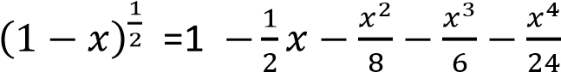
Now
√

√

√

(

)
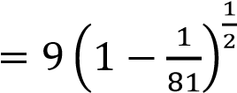
Comparing 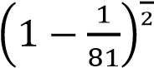 with 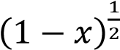
⇨ x = 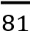
Substituting for x
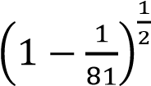
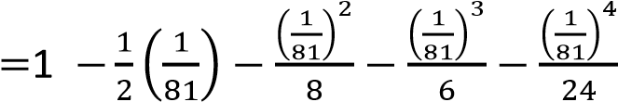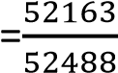
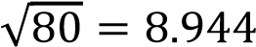 (4 S.F)
Not the termx3 has been neglected as it does not affect the answer to 4 significant figured
Example 14
John operates an account with a certain bank which pays a compound interest rate of 13.5% per annum. He opened the account at the beginning of the year with sh. 500,000 and deposits the same amount of money at the beginning of every year. Calculate how much he will accumulate at the end of 9 years. After how long will the money have accumulated to sh. 3.32 millions? Solution
The 1st deposit will grow to
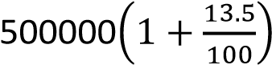= 500000 x 1.135
2nd deposit will grow to 500000 x 1.135² n^{th} deposit will grow to 500000 x 1.135^{n}
9th deposit will grow to 500000 x 1.135⁹ The total = 500,000[1.135 +1.135² + … +
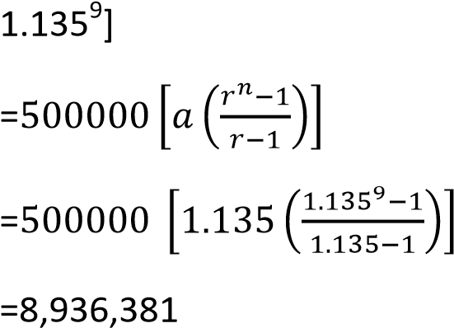
Finding how long it will take the money to accumulate to sh. 3,320,000
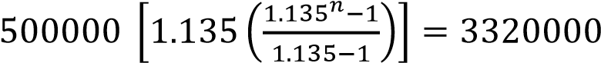
n = 4.6years
Example 15
Expand (1 + x)⁻² in descending powers of x including the term x⁻⁴. If x = 9 find the percentage error in using the first two terms of the expression.
Solution
From
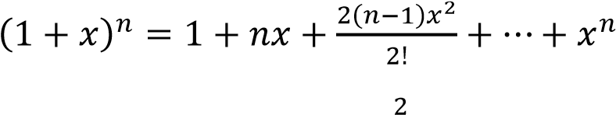
Now (1 + x)⁻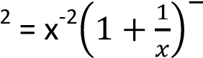
x⁻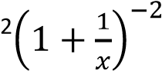
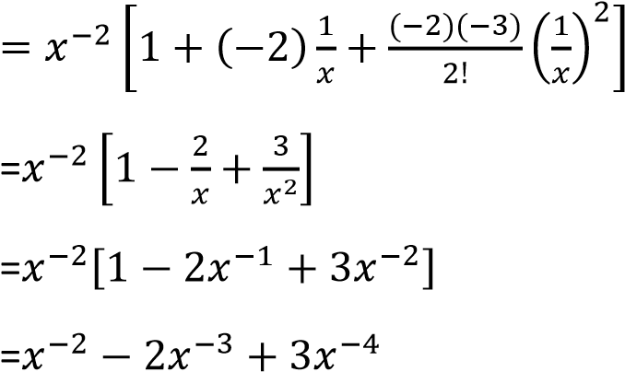
If x = 9
(1 + x)⁻²=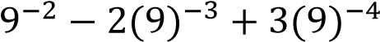
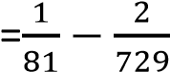(using the first 2 terms)
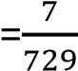
The exact value is 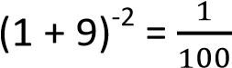
Error = 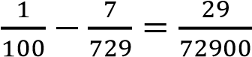
%error = 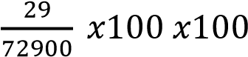= 3.978%(3d.p)
Example 16
(a) Find the three terms of the expansion (2 – x)⁶ and use it to find (1.998)⁶ correct to two decimal places (06 marks) Example 17
(a) Prove by induction
(2 – x)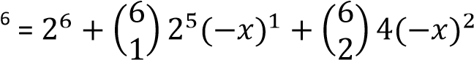
= 64 -192x + 240x²
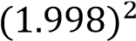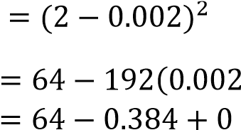
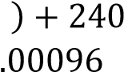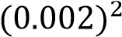

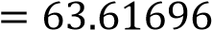
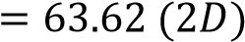

1.3 + 2.4 + … + n(n + 2) = 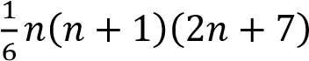 for all values of n.
Suppose n = 1
L.H.S = 1 x 3 = 3
R.H.S = 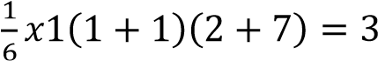
L.H.S = R.H.S, hence the series holds for n =1
Suppose n = 2
L.H.S= 1 x 3 + 2 x 4 = 11
R.H.S = 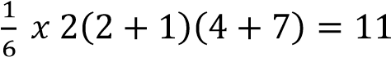
L.H.S = R.H.S, hence the series holds for n =2 Suppose n = k
1.3 + 2.4 + … + k(k + 2) = 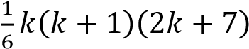
For n = k + 1
1.3 + 2.4 + … + k(k + 2), (k + 1)(k 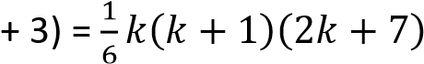+(k +1)(k + 3)
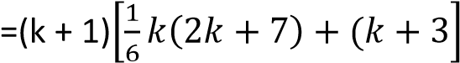
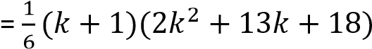
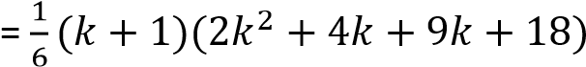
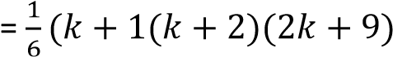
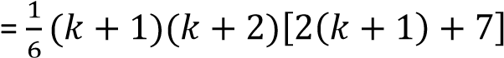
Which is equal to R.H.S when n = k + 1
It holds for n = 1, 2, 3 …, hence it holds for all integral values of n.

(b) A man deposits Shs. 150,000 at the beginning of every year in a micro finance bank with the understanding that at the end of the seven years he is paid back his money with 5% per annum compound interest. How much does he receive?
Using amount, A = P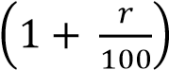
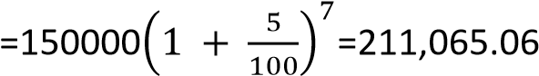
Alternatively
1st year
P = 150,000
He is paid back principal plus interest; P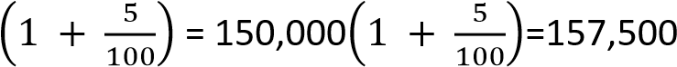
2nd year
P = 157, 500
He is paid back principal plus interest; P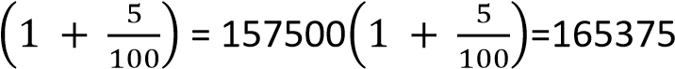
3rd year
P = 165375
Interest = 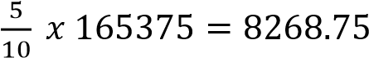
He is paid back principal plus interest; P
4th year
P=173643.75
He is paid back principal plus interest; P
5th year
P =182325.94
His paid back principal plus interest; P
6th year
P = 191442.23
He is paid back principal plus interest; P
7th year
P = 201014.35
He is paid back principal plus interest; P by the 7th year he has accumulated shs. 211,065.06

Example 18
Expand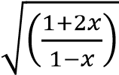 up to the term x². Hence find the value of to four significant figures. (12marks)
√
(

)
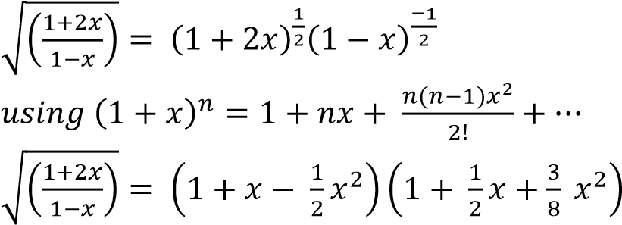
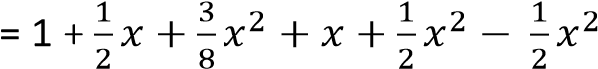
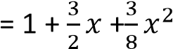
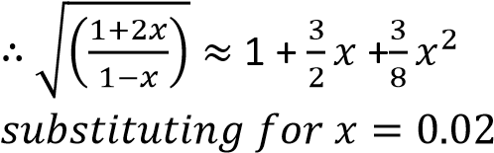
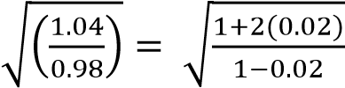
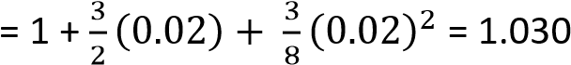

Revision exercise 5
- Given that the ratio of the 3rd to the 4th term of the expansion (2+3x)n is 5:14, find the value of n when x = . [n= 16]
- Expand (3 – 4x)⁵ in ascending order of x up to and including the term x³. Hence evaluate (4.96)⁵ correct to 2 d.p. [3001.98]
- (a) Find the coefficient of x2 in the expansion of (1 – 2x)^{n} is 24 [4]
  - Find the term independent of x in the expansion of 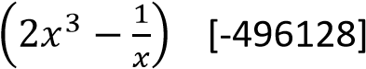
  - Use the binomial expansion to expand 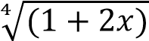 up to the term x³. Hence
evaluate correct to three decimal places [3.018]
√

√
(

)
- Expand up to and including the term x3. Hence find the value of 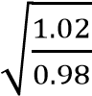 to four significant figures. Deduce the value of 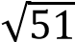 to 3 significant figures [1.0202,
7.14]
- Five millions shillings are invested each year at a rate of 15%. In how many years will it accumulate to more than 50millions?
[6years]
- Expand 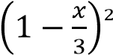 as far as x3. Hence

evaluate √ correct to 3 decimal places
[2.829]
- A man deposits sh. 800,000 into his saving account on which interest is 15% per annum. If he makes no withdraws, after how many years will his balance exceed sh.
8millions? [16.5 years]
- Determine the binomial expansion of
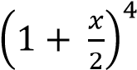. Hence evaluate (2.1)⁴ correct to 2 decimal places.[19.45]
- Determine the binomial expansion of
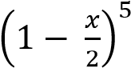. Hence evaluate (0.875)⁵ correct to four decimal places [0.5129]
- A financial credit society give a compound interest of 2% per annum to its members. If Bbosa deposits sh. 10000 at the beginning of every year. How much would he accumulate at the end of the fifth year if no withdraws within this period [sh.
530812]
- Expand 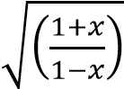 in ascending powers of x up
to a term x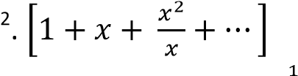
- (a) Using the expansion 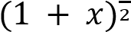 up to the term x³, find the value of to four decimal places [1.0392]
√

  - Express in the form 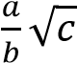. Hence
√

evaluate √ correct to 3 significant figure
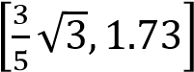
- (a) obtain the first four non – zero terms of the binomial expansion in ascending powers
of x of 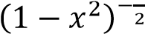 give that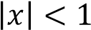
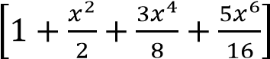
  - show that, when x = ; 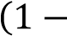
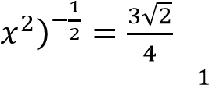
  - substitute x = into your expansion and

hence obtain an approximation of √ , give your answer to five decimal places
[1.41415]
- (a) show that 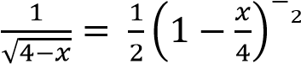
  - Write the first three terms in the
binomial expansion of 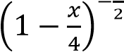 in
ascending power of x stating the range for which this expansion is valid.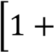
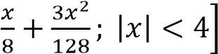
  - Find the first three terms in the
expansion of 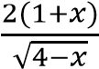 in ascending power

P a g e | 28 of x for small values of x.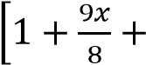 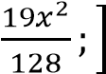

TOPIC 2/4: Random Variables
Competency: The learner models and analyses the outcomes of random phenomena through determining probabilities and expected values for prediction of uncertainties in real life.
Contents
Competency: The learner models and analyses the outcomes of random phenomena through
determining probabilities and expected values for prediction of uncertainties in real life. ........................ 1
Definition of Random Variables .................................................................................................................... 2
Discrete probability distribution ............................................................................................................... 2
Properties of discrete probability density functions ............................................................................ 3
Expectation of x, E(x) or mean of discrete random .............................................................................. 8
Variance, Var(x) of discrete probability distribution .......................................................................... 13
Properties of the variance for discrete random variable .................................................................... 16
Cumulative distribution function F(X) for discrete random variables ................................................ 18
Continuous probability distribution ........................................................................................................ 21
Finding Probabilities of continuous random variable ......................................................................... 23
Finding p.d.f from a sketch graph of a continuous random variable .................................................. 28
Expectation or mean of X of continuous random variable ................................................................. 31
Variance of X of continuous random variables ................................................................................... 41
Median of continuous random variables ............................................................................................ 47
Cumulative distribution function, F(x) of continuous random variables ............................................ 49
Finding f(x) from F(X) of continuous random variables ...................................................................... 57
Uniform or rectangular distribution ....................................................................................................... 60

Definition of Random Variables
A random variable is a function that assigns a numerical value to each outcome of a random event, linking the outcomes of chance to a measurable quantity.
For example, when rolling a die, a random variable can assign the numbers 1 through 6 to each face of the die, which allows for mathematical and statistical analysis.

Types of Random Variables
- Discrete Random Variable
Takes countable values (like integers).
Examples
  - Number of heads when flipping 3 coins.
  - Number of students absent in a class.
  - Rolling a die → possible values: 1, 2, 3, 4, 5, 6.
  - the number of phone calls received in a 15-minute period.
- Continuous Random Variable
Takes uncountably infinite values within an interval.
Examples
  - Height of students in a school.
  - Time taken to run a marathon.
  - Temperature measured during the day.
  - the exact time it takes to complete an exam.

Discrete probability distribution
It a function or table that assigns probabilities to each possible value of a discrete random variable.
Focus: It describes the likelihood of each outcome.
For example tossing a fair coin, P(H) = P(T) = ½
Differences between discrete random variable and discrete probability distribution
Aspect | Discrete Random Variable | Discrete Probability Distribution
Meaning | Represents possible outcomes of an experiment | Assigns probabilities to those outcomes
Nature | Variable (values only) | Function/table (values + probabilities)
Example | Number of heads in 3 coin tosses | Probability of getting 0, 1, 2, or 3 heads
Role | Defines the sample space | Quantifies likelihood of each outcome

Properties of discrete probability density functions
- P(X=x)0
Examples 1
A discrete random variable has a probability function 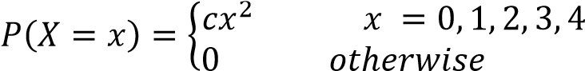
Find the value of c and draw the graph of P(X = x)
Solution
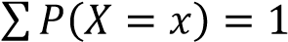
c(0²) + c(1²) + c(2²) + c(3²) + c(4²) = 1 c + 4c + 9c + 16c = 2
c = 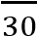
Example 2
A discrete random variable has probability function
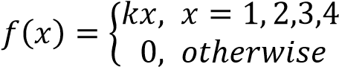 , find the value of k and draw the graph of f(x)
Solution
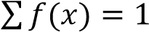
k + 2k + 3k + 4k = 1
k = 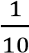
Example 3
A random variable X of a discrete probability distribution given by
P(X=1) = 0.2, P(X=2) = P(X=3) = 0.1, P(X=4) = P(X=5) = c
Find the value of the constant c and draw the graph of P(X = x)
Solution
0.2 + 0.1 + 0.1 + c + c = 2; c = 0.3
Example 4
A discrete random variable has a probability function
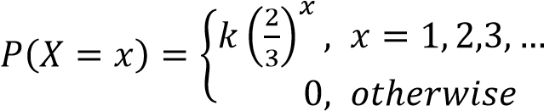
Find the value of k
Solution
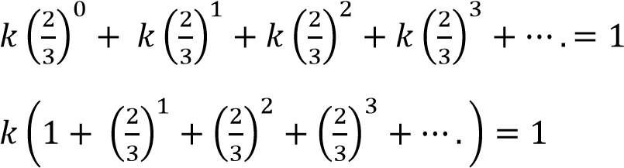
Sum to infinity = 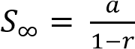
⇨ 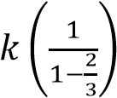= 1; k =
Finding probabilities of discrete random variable
Example 5
A discrete random variable has a probability distribution
y | -3 | -2 | -1 | 0 | 1
P(Y=y) | 0.1 | 0.25 | 0.3 | 0.15 | a
Find
(i) value of a (ii) P(-3 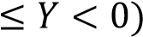 ( iii) P(Y>-1) (iv) P(1<Y<1) (v) mode Solution
- 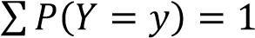
0.1 + 0.25 + 0.3 + 0.15 + a = 1; a = 0.2
- P(-3 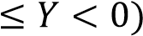 = P(Y= -3) + P(Y = -2) + P(Y = 1) = 0.1 + 0.25 + 0.3 = 0.65
- P(Y> -1) = P(Y = 0) + P(Y = 1) = 0.15 + 0.2 = 0.3 5
- P(-1< Y<1) = P(Y = 0) = 0.15
- mode is the value y with the highest probability, mode = -1
Example 6
A discrete ran dom variable X ha s a probability di stribution
X | 1 | 2 | 3 | 4 | 5
P(X = x) | 0.15 | 0.20 | 0.15 | c | 0.1

Find
(i) the value of x (ii) P(X<4) (iii) P(X4 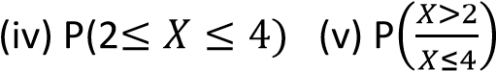(vi) mode
Solution
- 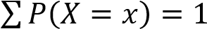
0.15 + 0.20 + 0.15 + c + 0.1 = 1; c = 0.4
- P(X<4) = P(X=1) + P(X= 2) + P(X = 3) = 0.15 + 0.20 + 0.15 = 0.5
- P(X<4) = P(X=1) + P(X= 2) + P(X = 3) + P(X= 4) = 0.15 + 0.20 + 0.15 + 0.4 = 0.9
- P(2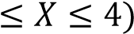 = P(X = 2) + P(X = 3) + P(X = 4) = 0.20 + 0.15 + 0.4 = 0.75
(vi) the mode is a value with highest probability = 4
Example 7
A discrete random variable X has a probability function
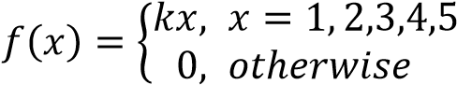
Find (i) the value of k (ii) P(X = 3) (iii) P(X3) (iv) P(X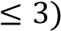 (v) P(13) (vi) P.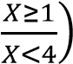
Solution
- 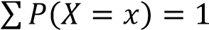
k + 2k + 3k + 4k + 5k = 1; k = 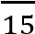
- P(X=3) = 3k = 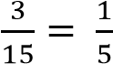
- P(X3)= P(X=3) + P(X=4) + P(X = 5) = 3k + 4k + 5k = 12k = 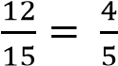
- P(X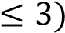= P(X= 1) + P(X=2) + P(X = 3) = k + 2k + 3k =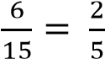
- P(13) = P(X=2) + P(X = 3) =2k + 3k =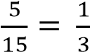

Revision exercise 1
- A discrete random variable X has probability distribution
x | 1 | 2 | 3 | 4 | 5
P(X=x) | 0.2 | 0.25 | 0.4 | a | 0.05
Find (i) value of a = 0.1 (ii) P(1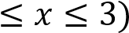=0.85 (iii) P(X>2) =0.55 (iv) P(2<X<5) = 0.5 (v) mode =3
- A random variable x of a discrete pdf is given by P(X x) = kx, x = 12, 13, 14 Write the probability distribution and find the value of k

k =

x | 12 | 13 | 14
P(X=x) | 12k | 13k | 14k
- A random variable Y of discrete probability distribution is given by
P(Y = 3) = 0.1, P(Y = 5) = 0.05, P(Y=6) = 0.45 P(Y = 8) = 3P(Y = 10). Find P(Y=10) = 0.1
- A discrete random variable has a distribution
x | 1 | 2 | 3 | 4 | 5
P(X=x) | 0.1 | 0.3 | k | 0.2 | 0.05
Find
(i) value of k = 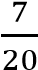(ii) P(X4) = 0.25 (iii) P(X<1)=0 (iv) P(2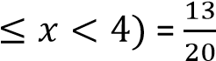
- Write out the probability distribution for each of these variables

  - The number of heads X obtained when two fair coins are tossed
x | 0 | 1 | 2
P(X=x) | 0.25 | 0.5 | 0.25

  - The number of tails, X obtained when three fair coins are tossed.
x | 0 | 1 | 2 | 3
P(X=x) | 0.125 | 0.375 | 0.375 | 0.125

- A drawer contains 8 brown socks and 4 blue shocks. A sock is taken from the drawer at random, its colour is noted and it is then replaced. The procedure is performed twice more. X is the random variable for the number of brown socks taken. Find the probability distribution for X.
x | 0 | 1 | 2 | 3
P(X=x) | 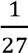 |  |  | 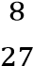

- The discrete random variable R has a p.d.f is given by P(R=r) = c(3 – r), r = 0, 1, 2, 3
Find (i) value of c 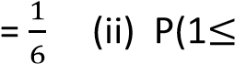R<3) = 0.5
- A discrete random variable has probability function
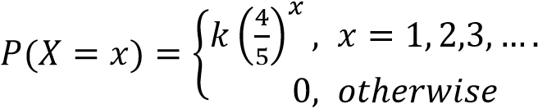 , find the value k = 0.2.
Solutions to revision exercise
5 Write out the probability distribution for each of these variables
  - The number of heads X obtained when two fair coins are tossed
S =(TT, TH, HT, HH)
P(X= 0) = 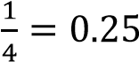, P(X= 1) = 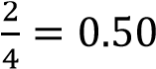, P(X= 2) 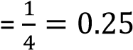
Probability distribution table

x | 0 | 1 | 2
P(X=x) | 0.25 | 0.5 | 0.25

  - The number of tails, X obtained when three fair coins are tossed.
S = (TTT, TTH, THT, HTH, THH, HTH, HHT, HHH)
Probability distribution table
number of heads, x | 0 | 1 | 2 | 3
P(X=x) | 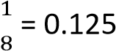 | 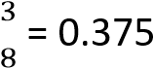 | 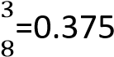 | 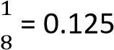
- A drawer contains 8 brown socks and 4 blue shocks. A sock is taken from the drawer at random, its colour is noted and it is then replaced. The procedure is performed twice more. X is the random variable for the number of brown socks taken. Find the probability distribution for X.
Let X’ represent blue shocks
P(X = 0) = P(X’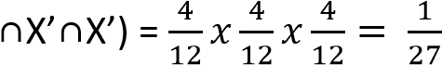
P(X=1) = P(X
P(X=2) = P(X
P(X = 3)= P(X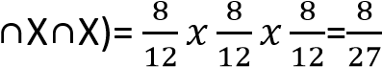
Probability distribution table
x | 0 | 1 | 2 | 3
P(X=x) | 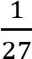 |  |  | 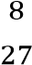
- The discrete random variable R has a p.d.f is given by P(R=r) = c(3 – r), r = 0, 1, 2, 3

Find (i) value of c 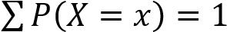
3c +2c + c = 3
c=
(ii) P(1R<3) = 2c + c = 3c = 3 x 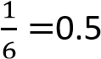
- A discrete random variable has probability function
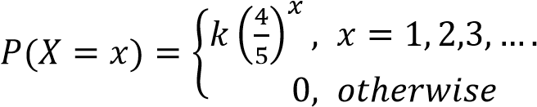 , find the value k.
Solution
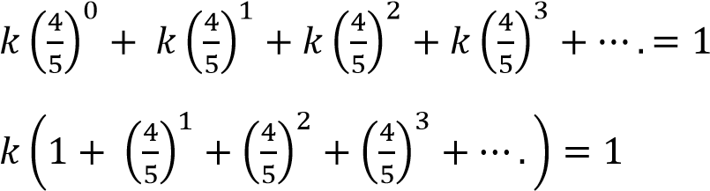
Sum to infinity = 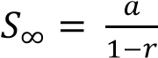
⇨ 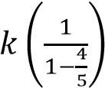= 1; k = 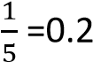

Expectation of x, E(x) or mean of discrete random The expected value of x is given by E(x) = 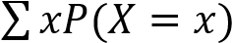
Example 8
A discrete random variable has a probability distribution
x |  | -2 |  | -1 |  | 0 |  | 1 |  | 2
P(X = x) |  | 0.3 |  | 0.1 |  | 0.15 |  | 0.4 |  | 0.05
Find expectation, E(x)
Solution
E(X) = (-2 x 0.3) + (-1 x 0.1) + (0 x 0.15) + (1 x 0.4) + (2 x 0.05) = -0.2
Example 9
The discrete random va riable Y has a probability distribution is given by P(Y = y) = cy, y = 1 2,3,
P(Y = y) = c(8-y), y = 4, 5 , 6, 7
Find (i) the value of c (ii) mean, μ
Solution
y | 1 |  | 2 |  | 3 | 4 | 5 |  | 6 |  | 7
P(Y = y) | c |  | 2c |  | 3c | 4c | 3c |  | 2c |  | c
c + 2c + 3c + 4c + 3c +2c + c = 1 c = 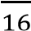
(ii) E(Y) = 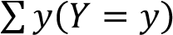 = 1 x c + 2 x 2c + 3 x 3c + 4 x 4c + 5 x 3c + 6 x 2c + 7x c = 64c
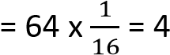
Example 10
A fair coin is tossed three times write out the probability distribution for the number of heads, X, obtained and hence obtain the expected number of heads
Solution
S = (TTT, TTH, THT, HTH, THH, HTH, HHT, HHH)
Probability distribution table
number of heads, x | 0 | 1 | 2 | 3
P(X=x)
E(X) = ∑ ( ) = (0 x )

Example 11
A family plans to have 4children. Given that X is the number of girls in the family. Find the expected number of girls
Solution
S = (BBBB, BBBG, BBGB, BGBB, GBBB, BBGG, BGGB, BGBG, GGBB, BGGB, GBBG, BGGG, GBGG, GGBG,
GGGB GGGG)
Probability distribution table
Number of girls, x | 0 | 1 | 2 | 3 | 4
P(X=x) | 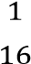 | 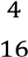 | 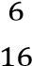 | 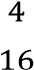 | 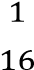
E(X) =
Example 12
A box A contains 4 red sweets and 3 green sweets. Box B contains 5 red sweets and 6 green sweets. Box A is twice more likely to be picked as Box B. If a box is chosen at random and two sweets are removed from it, one at a time without replacement.
  - Find the probability that two sweets removed are of the same colour.
P(same colour) = P(A∩R₁∩R₂) + P(A∩G₁∩G₂) + P(B∩R₁∩R₂) + P(B∩B₁∩B₂)

  - (i) construct a probability distribution table for the number of red sweets removed Let x = number of red sweets removed
P(X =0) = P(A∩G₁∩G₂) + P(B
P(X=1) = P(A∩R₁∩G₂) + P(A∩G₁∩R₂) + P(B∩R₁∩G₂) + P(B∩G₁∩R₂)
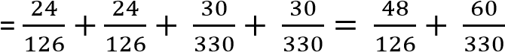
= 0.5628
P(X=2) = P(A

Probability distribution table
x | 0 | 1 | 2
P(X= x) | 0.1861 | 0.5628 | 0.2511

(ii) find the mean number of red sweets removed
Mean = 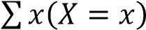 = 0 x0.1861 + 1 x 0.5628 + 2 x 0.2511 = 1.065

Revision exercise 2
    - A discrete random variable X has a probability distribution.
x | 0 | 1 | 2 | 3 | 4
P(X= x) |  | 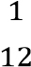
Find E(X) = 2.25
    - A discrete random variable X ha probability distribution
x | 5 | 6 | 7 | 8 | 9
P(X=x) | 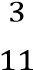 | 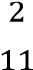 | 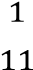 | 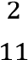 | 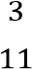
Find the mean = 7
    - A discrete random variable X has a probability distribution

    - A discrete random variable has a probability distribution
x | 0 | 1 | 2 | 3
P(X=x) | c | c² | c²+c | 3c² + 2c
Find (i) the value of c= 0.2 (ii) expectation of c=2.08
    - Find the expected number of heads when two fair coins are tossed (E(x) 1)
    - A family plans to have 3 children. Given that x is the number of boys in the family. Find the expected number of boys (=1.5)
    - If X is a random variable for the product of the scores on two tetrahedral dice, where the score is the number on which the die lands, find the expected score for the throw (=6.25)
    - A bag contains 5 black counters and 6 red counters. Two counters are drawn at random, one at a time without replacement. Find the expected number of red counters. ( = 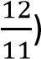
    - An unbiased tetrahedral die is tossed once. If it lands on a face marked 1, the player has to pay 10,000/=. If it lands on marked with 2 or 4 the player wins 5000/= and if it lands on a 3, the player wins 3000/=. Find the expected gain in one throw.
    - A discrete random variable X can take on values 10 and 20 only. If E(X) = 16. Write out the probability distribution for X (P(X=x) = 0.4 and P(X=x) = 0.6)
    - A discrete random variable X can take on values 0, 1, 2, and 3 only. If E(X) = 1.4, P(X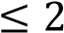) =
0.9 and P(X1) = 0.5. Find (i) P(X=1) = 0.3 (ii) P(X =0) = 0.2
12. The discrete random variable Y has a probability distribution is given by
P(Y=y) = cy, y = 1, 2, 3, 4
Find (i) value of c = 0.1 (ii) E(X) = 13. A discrete random variable has p.d.f
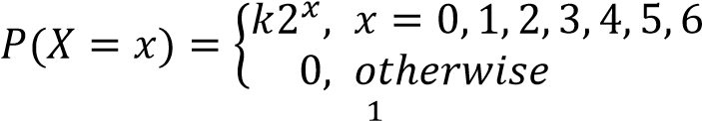 ,
Find (i) value of k = , (ii) mean = 5
14. A discrete random variable X has a probability distribution
x | 0 | 1 | 2 | 3 | 4 | 5
P(X= x) | 0.11 | 0.17 | 0.2 | 0.13 | p | 0.09
Find (i) the value of p = 0.3 (ii) Expected value of X (= 2.6)
Solutions to revision exercise 2
- A discrete random variable X can take on values 10 and 20 only. If E(X) = 16. Write out the probability distribution for X Let P(X=10) = a and P(X=20) = b a+b = 1 a = (1-b)………………. (i) 10a + 20b = 16 ……. (ii)
Eqn. (i) and eqn. (ii)
10(1-b) + 20b = 16 10 + 20b = 16 b = 0.6 a = 1- 0.6 = 0.4
Probability distribution:(P(X=x) = 0.4 and P(X=x) = 0.6)
- A discrete random variable X can take on values 0, 1, 2, and 3 only. If E(X) = 1.4, P(X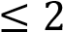) = 0.9 and
P(X1) = 0.5. Find (i) P(X=1) (ii) P(X =0) Let P(X = 0) = a, P(X=1)=b, P(X=2)= c p(X = 3) = d a + b + c + d = 1 ……………. (i) P(X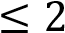) = a + b+ c = 0.9 … (ii)

Eqn. (i) and eqn. (ii) d = 0.1
P(X1) = a + b = 0.5 ……. (iii)
Eqn. (i) and eqn. (iii) 0.5 + c + 0.1 = 1 c = 0.4
E(X) = 0 x a + 1 x b + 2 x c + 3 x 0.1 = 1.4
= b + 2c + 0.3 = 1.4
b + 2c = 1.1 b + 2 x 0.4 = 1.1 b = 0.3
a = 0.5 – 0.3 = 0.2
Hence, (i) P(X=1) = 0.3 (ii) P(X =0) = 0.2
- The discrete random variable Y has a probability distribution is given by
P(Y=y) = cy, y = 1, 2, 3, 4
Find (i) value of c = 0.1 (ii) E(X) =
(i) 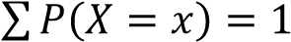
c + 2c + 3c + 4c = 1
10c = 1; c= 0.1
(ii) E(X) =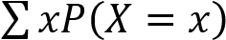= 1 x 0.1 + 2 x 0.2 + 3 x 0.3 + 4 x 0.4 =3

- A discrete random variable has p.d.f
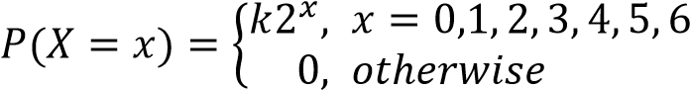 ,
Find
(i) (i) value of k = 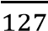,
k(2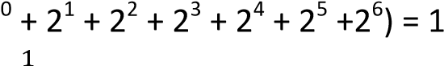
k = 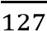
(ii) Mean = 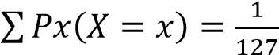(0 x 1 + 2 x 2 + 3 x 8 + 4 x 16 + 4 x 32 + 6 x 64) = 5.01
- A discrete random variable X has a probability distribution
x | 0 | 1 | 2 | 3 | 4 | 5
P(X= x) | 0.11 | 0.17 | 0.2 | 0.13 | p | 0.09
Find
(i) the value of p
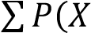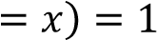
0.11 + 0.17 + 0.2 + 0.13 + p + 0.09 = 1 p = 0.3
(ii) Expected value of X
E(X) =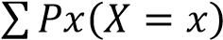 = 0.11x0 + 0.17x1 + 0.2x2 + 0.13x3 + 0.3 x 4 + 0.09x5= 2.61
Properties of the mean
    - E(a) = a
    - E(ax) = aE(x)
    - E(ax + b) = aE(x) + b
    - E(ax - b) = aE(x) - b
Example 13
A random variable X of discrete probability distribution is given by
x | 1 | 2 | 3 | 4
P(X=x) | 0.1 | 0.2 | 0.3 | 0.4
Find
- E(x) = 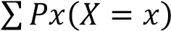 = 1 x 0.1 + 2 x 0.2 + 3 x 0.3 + 4 x 0.4 = 3
- E(3x) = 3E(x) = 3 x 3 = 9
- E(4x + 6) =4E(x) + 6 = 4 x 3 + 6 = 18
Example 14
A random variable X of discrete probability distribution is given by
x |  | -1 |  | 0 |  | 1 |  | 2
P(X= x) |  | 0.25 |  | 0.10 |  | 0.45 |  | 0.20
Find
- P(-1 X <1) = P(X= -1) + p(X = 0) = 0.25 + 0.10 =  - E(X) =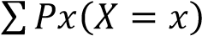 = -1 x 0.25 + 0 x 0.10 + 1 x 0  - E(6x – 2) = 6E(X) – 2 = 0.6 x 6 – 2 = 1. 6  Variance, Var(x) of discrete p robab ility distr ibution Var(x) = E(X²) = [E(x)]² where E(X² ) = 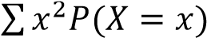  Example 15  A discrete random variable X ha s a pro bability di stribution |  |  |  |  |  | 0.35  .45 + 2 | x 0.20 = 0.6
x | 1 |  | 2 |  | 3 |  | 4 |  | 5
P(X=x) | 0.1 |  | 0.3 |  | 0.2 |  | 0.3 |  | 0.1
Find
  - The mean = 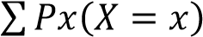 = 1 x 0.1 + 2 x 0.3 + 3 x 0.2 + 4 x 0.3 + 5 x 0.1= 3 (ii) Var(x)
E(X²) =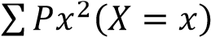 = 1² x 0.1 + 2² x 0.3 + 3² x 0.3 + 4² x 0.3 + 5² x 0.1 = 10.4
Var(X) = 10.4 – (3)² = 1.4

Example 16
The discrete random variable Y has a probability distribution is given by P(Y =y), y= -3, -2, -1, 0, 1, 2,3
Find: (i) value of c (ii) mean (iii) standard deviation
Solution
y | -3 | -2 | -1 | 0 | 1 | 2 | 3
P(Y= y) | 3c | 2c | c | 0 | c | 2c | 3c
3c +2c + c+ c + 2c + 3c = 1; c = 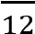
  - Mean = 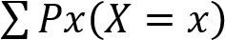 = -3 x 3c + -2 x 2c + -1 x c + 0 x 0 + 1 x c + 2 x 2c + 3 x 3c = 0
  - E(X²) = (-3)² x 3c + (-2)² x 2c + (-1)² x c + (0)² x 0 + (1)² x c + (2)² x 2c +(3)² x 3c = 72 x 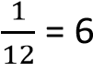
Var (x) = E(X²) – (E(x))² = 6 – (0)² = 6
S.D = 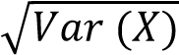 =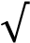 = 2.45
Example 17
Two marbles are drawn without replacement from a box containing 3 red marbles and 4 white marbles.
The marbles are randomly drawn. If X is the random variable for the number of red marble drawn find
  - Expected number of red marbles
P(X= 0) = P(WW) = 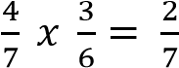
P(X= 1) = P(WR) + P(RW) = 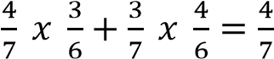
P(X= 2) = P(R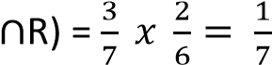
The probability distribution table
x | 0 | 1 | 2
P(X=x)
E(x) = ∑ ( ) = =

  - Standard deviation of X
E(x²) =
Var (x) = E(x²) 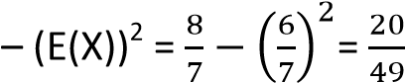
S.D = 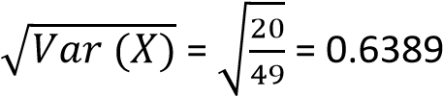
Example 18
A vendor stocks 12 copies of a magazine each week and the probability for each possible total number of copies sold is shown below
Number of copies | 9 | 10 | 11 | 12
probability | 0.2 | 0.35 | 0.30 | 0.15
- Estimate the mean and variance of the number of copies
Mean = 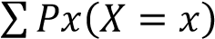 = 9 x 0.2 + 10 x 0.35 + 11 x 0.3 + 12 x 0.15 = 10.4
E(X²) = 9² x 0.2 + 10² x 0.35 + 11² x 0.3 + 12² x 0.15 =109.1
Var(x) = 109.1 – (10.4)² = 0.94
- The vendor buys the magazine at 8,500/= and sells at 14,500/=. Any copies not sold are destroyed. Construct a probability distribution table for vendor’s weekly profit and hence find the expected weekly profit
Profit = S.P – C.P
Profit for 9 copies = 9 x 14,500 – 12 x 8500 = 28500
Profit for 10 copies= 10 x 14,500 – 12 x 8500 =43000
Profit for 11 copies= 11 x 14,500 – 12 x 8500 = 57500
Profit for 12 copies= 12 x 14,500 – 12 x 8500 = 72000
y | 28500 | 43000 | 57500 | 72000
P(Y=y) | 0.2 | 0.35 | 0.30 | 0.15
E(Y) = 0.2 x 28500 + 0.35 x 43000 + 0.30 x 57500 + 0.15 x 72000 = 48000/=

Example 19
The table below shows the number of red and green balls put in three identical boxes A, B and C.
Boxes | A | B | C
Red balls | 4 | 6 | 3
Green balls | 2 | 7 | 5
A box is chosen at random and two balls are then drawn from it successively without replacement. If the random variable X is “the number of green balls drawn”.
  - Draw a probability distribution table for X (06marks) Using combination
P(X = 0) = 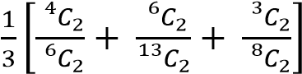
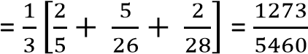
P(X = 1) = 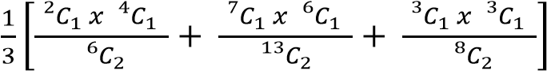
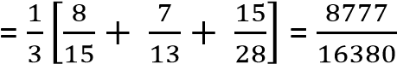
P(X = 2) = 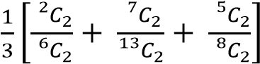
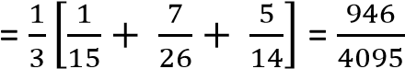
x | 0 | 1 | 2
P(X =x) | 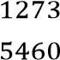 | 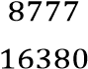 | 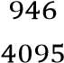

  - Calculate the mean and variance of X (06marks)
1 | 0 | 1 | 2
P(X =x) |  | 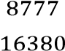 | 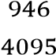
xP(X =x) |  |  | 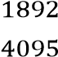
x²P(X =x) |  |  | 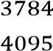
E(X) = = 0.9979
E(X²) = 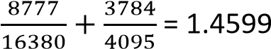
Var(X) = 1.4599 – 0.9979 = 0.4642
Properties of the variance for discrete random variable
- Var(a) = 0
- Var(aX) = a²Var(X)
- Var(aX + b) = a²Var(X)
- Var(aX – b) = a²Var(X)
Example 20
A discrete random variable X has a probability distribution
x | 1 | 2 | 3 | 4 | 5
P(X = x) | 0.2 | 0.25 | 0.4 | 0.1 | 0.05
Find
- Mean = 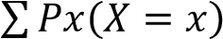 = 1 x 0.2 + 2 x 0.25 + 3 x 0.4 + 4 x 0.1 + 5 x 0.05 = 2.55
- The variance
E(X²) = 1² x 0.2 + 2² x 0.25 + 3² x 0.4 + 4 ² x 0.1 + 5² x 0.05 = 7.65
Var(x) = E(X²) – (E(X))² = 7.65 – (2.55)² = 1.148
- Var (3x -2) = 3²Var(x) = 9 x 1.148 = 10.332

Example 21
A random variable X of a discrete probability distribution given by
x | 10 | 20 | 30
P(X = x) | 0.2 | 0.3 | 0.5
Find
- E(X) = 10 x 0.2 + 20 x 0.3 + 30 x 0.5 =22
- Var (X) = E(X²) – (E(X))²
E(X²) = 10² x 0.2 + 20² x 0.3 + 30² x 0.5 = 520
Var(x) = 520 – 22² = 36
- Var(4X + 3) = 4²Var(x) = 16 x 36 = 576

Revision exercise 3
- A random variable X of discrete probability distribution is given by
x | 1 | 2 | 3
P(X = x) | 0.2 | 0.3 | 0.5
Find (i) E(X) = 2.3 (ii) E(X²) = 5.9 (iii) Var (X) = 0.61
- A random variable X of discrete probability distribution is given by
x | -1 | 0 | 1 | 2
P(X = x) | 0.25 | 0.1 | 0.45 | 0.2
Find: (i) P(-1≤ X < 2) = 0.8 (ii) E(X) = 0.6 (iii) E(2x + 3) = 4.2
- A random variable X of a discrete probability distribution P(X = 0) = 0.05, P(X = 1) = 0.45 P(X = 2) = 0.5
Find: (i) E(X) = 1.45, (i) E(X²) = 2.45 (iii) Var (X) = 0.348
- A random variable X of discrete probability distribution is given by P(X = 1) 0.1, P(X= 2) = 0.2,
P(X = 3) = 0.3, P(X =4)= 0.4
Find (i) E(X) = 3 (ii) Var (X) = 1 (iii) P(X = 2/X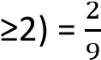
- The discrete random variable Y has a probability distribution P(Y = y) = k =1, 2, 3, 4, 5,6 Find (i) mean, μ = 3.5 (ii) E(3X +4) = 15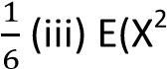)=14.5 (iv) standard deviation = 1.708
- The discrete random variable R has a probability distribution is given by
P(R = r) = ; r = 0, 1, 2, 3
Find (i) mean, 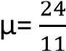, E(R2) = 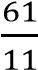(iii) E(3R-2) = 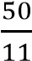
- The discrete random variable R has a probability distribution given by
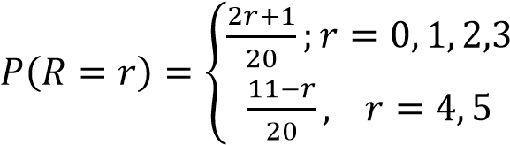
Find (i) E(R) = 2.55, (ii) Var(R) = 1.45
- The discrete random variable X has a probability distribution given by
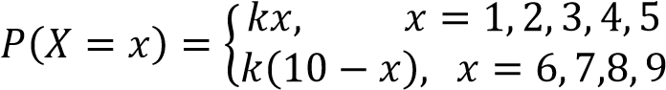
Find (i) constant, k = 0.04, (i) E(X) = 5 (iii) Var(X) = 4
- The discrete random variable X has a probability distribution is given by
P(X =x) = kx, x = 1, 2, 3,…..n ; where k is a constant
Show that k = 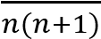, hence find in terms of n the mean X = 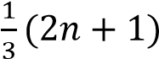
- A random variable X of a discrete probability distribution given by
P(X = 0) = P(X=1) = 0.1, P(X = 2) = 0.2, P(X= 3) = P(X = 4) = 0.3. Find Var (X) = 1.64
- A random variable X of a discrete probability distribution given by P(X = 2) = 0.1; P(X= 4) = 0.3; P(X = 6) = 0.5; P(X = 8) = 0.1. Find Var (X) 2.56

Cumulative distribution function F(X) for discrete random variables F(X) is given by FX = 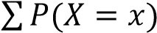
Note F(+) = 1 where + is the upper limit.
Example22
A discrete random variable has a probability distribution
x | 1 |  | 2 |  | 3 |  | 4 |  | 5
P(X = x) | 0.2 |  | 0.25 |  | 0.4 |  | 0.1 |  | 0.05
Find the cumul ative distribution function
Solution
x | 1 |  | 2 |  | 3 |  | 4 |  | 5
F(X)) | 0.2 |  | 0.45 |  | 0.85 |  | 0.95 |  | 1
Example 23
The random variable X has a cumulative function below

X |  | -1 |  | 0 |  | 1 |  | 2
F(X) |  | 0.25 |  | 0.35 |  | 0.80 |  | 1
Find the probability distribution function
X |  | -1 |  | 0 |  | 1 |  | 2
F(X) |  | 0.25 |  | 0.1 |  | 0.45 |  | 0.2
Example 24
A discrete random variable has a cumu lative distribution
x | 1 |  | 2 |  | 3 |  | 4 |  | 5
F(X) | 0.2 |  | 0.32 |  | 0.67 |  | 0.91 |  | 1
Find (i) probability distribution f unctio n
x | 1 |  | 2 |  | 3 |  | 4 |  | 5
F(X) | 0. 2 |  | 0.12 |  | 0.35 |  | 0.24 |  | 0.09
(ii) P(X = 3) =0.35
(iii) P(X>2) = P(X= 3) + P(X =4) + P(X=5) = 1- 0.12 = 0.68
Example 25
The random variab le X has a cumulativ e function
X |  | 1 |  | 2 |  | 3 |  | 4
F(X) |  | 0.1 |  | 0.5 |  | 0.8 |  | 1
Find (i) mean (ii) Var(X) (iii) m ode
Solution
X |  | 1 |  | 2 |  | 3 |  | 4
P(X = x) |  | 0.1 |  | 0.4 |  | 0.3 |  | 0.2
- Mean = 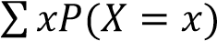 = 1 x 0.1 + 2 x 0.4 + 3 x 0.3 + 4 x 0.2 = 2.6
- Var(X)
E(X²) = 1² x 0.1 + 2² x 0.4 + 3² x 0.3 + 4² x 0.2 = 5.92
Var (X) = E(X²) – (E(X))² = 5.92 – (2.6)² = 0.84 (iii) Mode 2

Revision Exercise 4
- A discrete random variable has a cumulative distribution
x | 0 | 1 | 2 | 3 | 4
F(X) | 01 | 0.3 | 0.6 | 0.8 | 1
Find (i) E(X) = 15.2 (ii) Var(X)=1.56 (iii) Var(6X + 2) = 56.16
- The random variable X has a cumulative function below
x | 1 | 2 | 3 | 4
F(X) | 0.13 | 0.54 | 0.75 | 1
Find (i) P(X=2) = 0.41 (ii) P(X>1) = 0.87 (iii) P(X ≥ 3) = 0.46 (iv) P(X<2) = 0.13 (V)E(X) = 2.58
- A discrete random variable X has a cumulative distribution
x | 3 | 4 | 5 | 6 | 7
F(X) | 0.01 | 0.23 | 0.64 | 0.85 | 1
Find (i) probability distribution function (ii) Var (X) = 0.9724)
- A discrete random variable has a cumulative probability function F(X) = 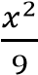, x = 1, 2, 3.
Find (1) F(2) = (ii) P(X = 2)= (iii) E(2X -3) = 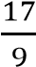
- A discrete random variable has a cumulative probability function. F(X) = k, x = 1, 2,3
Find the
  - constant k =
  - P(X<3) =
  - Standard deviation, σ = 0.816
- A discrete random variable has a cumulative probability function
F(X) = 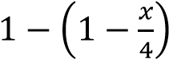 x = 1, 2, 3, 4
Find the
  - F(3) = 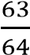
 | (iii) | Var (X) = 0.547
  - F(2) =

Continuous probability distribution
A probability density function (p.d.f) is continuous if it takes on values between an interval.
Properties of a continuous probability density functions
- 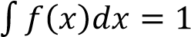
- f (x) ≥ 0
Example 26
A random variable X of continuous p.d.f is given by 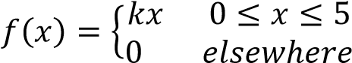
Find the value of k
Solution
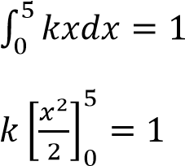

𝑘
.

/

k

𝑘

Example 27
A random variable X of a continuous p.d.f is given by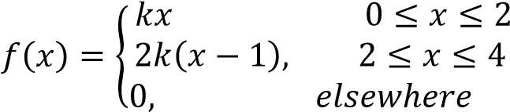
Solution
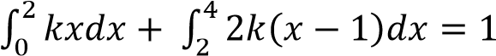

.

/

𝑘
2
.

/

.

/
3
=
1

k + 8k = 1; k=
2

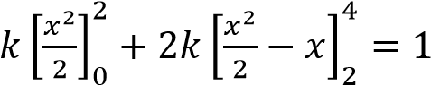
Sketching f(x)
- find the initial and final points of f(x)
- join the initial and final points of f(x) using a line or curve.

Note
- A line is in the form of y = mx + c
- A curve has a power of x being 2 and above or fractional power e.g. y = x².
- A curve has a positive coefficient of x² has a minimum turning point while a curve with a negative coefficient has a maximum turning point

Example 28
A random variable x of a continuous p.d.f is given by 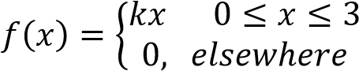
Find the value of the constant k and sketch f(x)
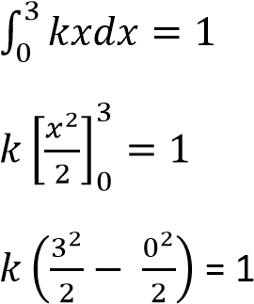
Solution

k =

When x = 0, f(x) =

𝑥

When x = 3, f(x) =

𝑥

3
x
0

f(x)

Example 29
A random variable X of continuous p.d.f is given by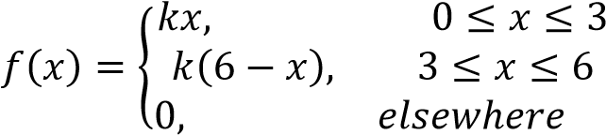
Find the value of the constant k and sketch x

Solution
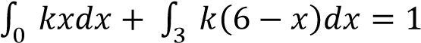

k =

Example
30

When x = 0, f(x) = k(0) = 0

When x = 3, f(x) = k(3) = 3k

Wh
en x = 6, f(x) = k(6
-
=
6)
0

f(x)

3
k

3 6 x
0

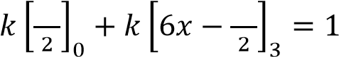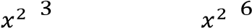
A random variable x of a continuous p.d.f is given by 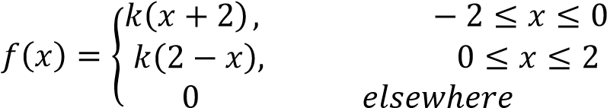



When x =
-
, f(x) = k
(
2
-
0

2+2) =

When x = 0, f(x) = k(0 +2) = 2k

When x = 2, f(x) = k(2
-
=
0
2)

f(x)

2
k

-
2
0 2 x

Find the value of k and sketch f(x)
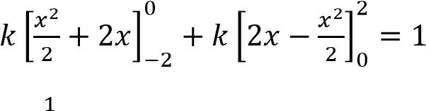
k =

Finding Probabilities of continuous random variable
Example 31
A random variable X of a continuous p.d.f is given by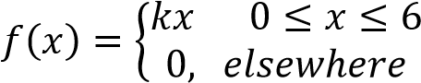
Find
(i) the value of k (ii) P(X > 4) (iii) P(X< 3) (iv) P(1< x < 3) (v) P.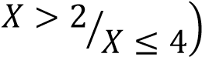
Solution
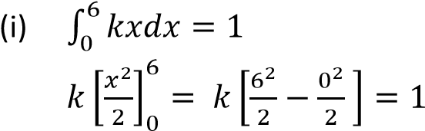
k = 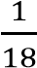
- P(X > 4) = 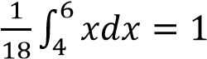
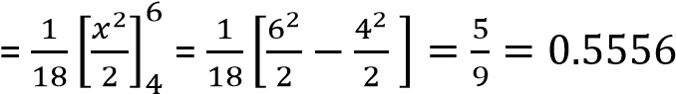
- P(X < 3) 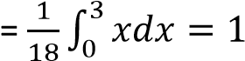
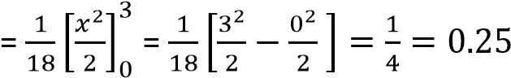




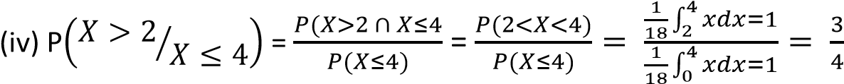

(
i
ii) 1 < x < 3)

=

∫
𝑥𝑑𝑥

=

0
𝑥

1

=

0

1

Sketch

f(x)

0
6 x

f(x) =

x(6
–

x)

Example 32
A random variable X of a continuous p.d.f is given by 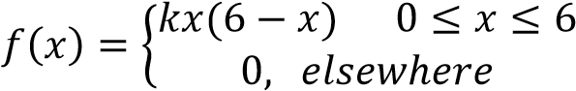
Find the (i) value of k and sketch f(x) (ii) P(X ≥ 5)
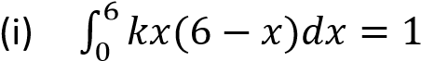
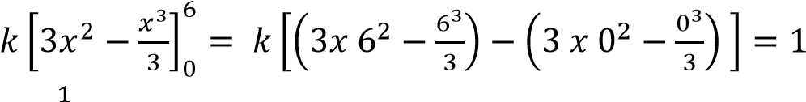
k = 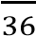
When x = 0, f(x) = 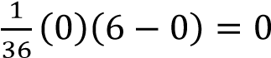
When x = 6, f(x) = 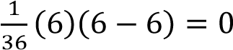
(ii) P(X 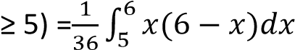
Example 33
A random variable of continuous p.d.f is given by 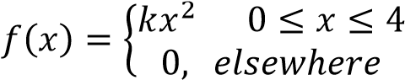
Find (i) value of k and sketch f(x) (ii) P(1 ≤ x ≤ 3)
Solution



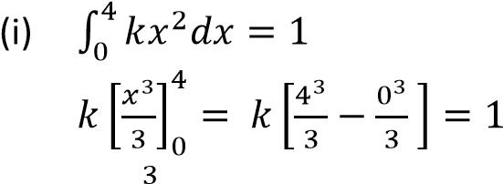
Sketch

⁄

f(x)

0
4 x

k = 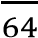
When x = 0, f(x) = 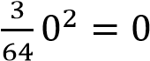
When x = 4, f(x) = 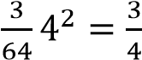
(ii) P(1 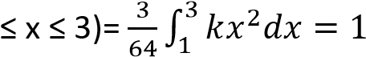
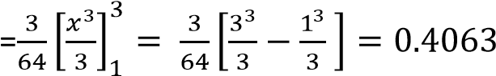
Example 34
A random variable X of a continuous p.d.f is given by 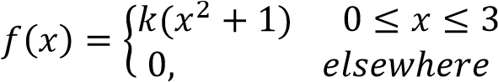
Find (i) value of k and sketch f(x) (ii) P(1 ≤ x ≤ 3)
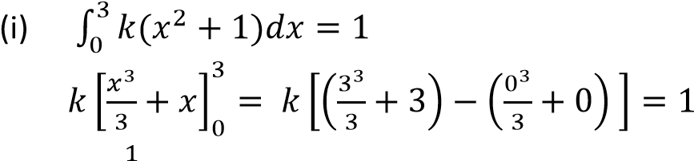
k =
When x = 0, f(x) = 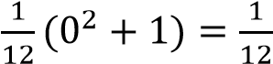
When x = 3, f(x) = 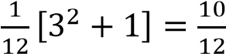
(ii) P(1 ≤ x ≤ 3)




0
3 x

⁄

f(x)

Example 35
A random variable X of continuous p.d.f is given by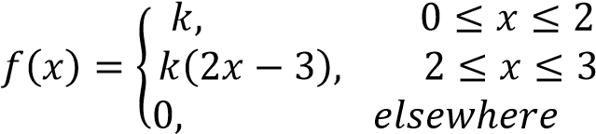 Find (i) value of k and sketch f(x) (ii) P(X<1) (ii) P(X > 2.5) (iv) .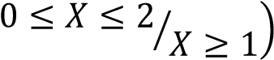
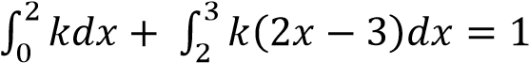
Solution

k =

When x = 0, f(x) = k =

When x = 2, f(x) = k =

When x = 3, f(x) =

(2
x3
-

3)

=

f(x)

0
2 3 x

f(x) =

⁄

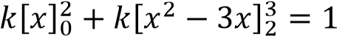
- P(X<1) =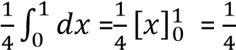
- P(X > 2.5) =
Example 36
A random variable X of continuous p.d.f is given by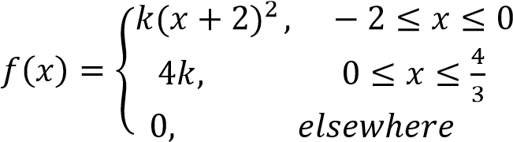
Find
- the value of the constant k and sketch f(x)
- P(-1 < x< 1) (iii) P(X > 1)
Solution




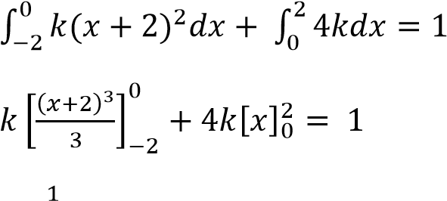
Sketch

f(x)

-
0
2

x

F(x) =

k =
When x = -2, f(x) = 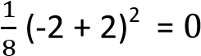
When x = 0, f(x) = 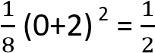
When x = , f(x) =4 x 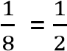
- P(-1 < x< 1) =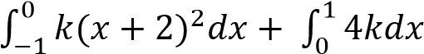
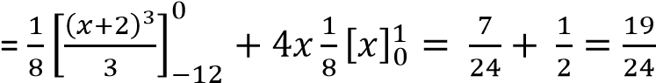
- P(X > 1) =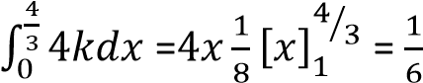
Finding the constant k from a sketch graph
Example 37
A random variable X of continuous p.d.f is given by 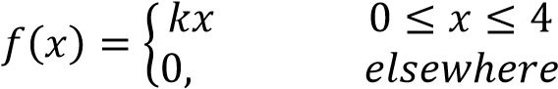
- Sketch and find the value of constant k
- Find (i) P(X ≤ 1) (ii) P(1 < x < 2)
Solution

(
a
)

When x = 0, f(x) = k x 0 = 0

When x = 4, f(x) = k x 4 = 4k

f(x)

4
k

0

4
x

Area under the curve = 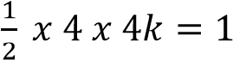
k =

Example 38

A random variable X of a continuous p.d.f is given by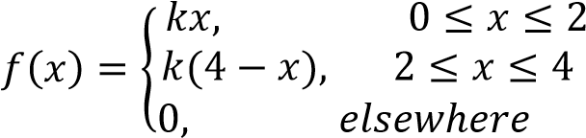
(
)
b)(i

P(X
≤

1)
=

∫
𝑥𝑑𝑥

=

0
𝑥

1

=

.

/

=

(
ii)
P(1 < x < 2)

=

∫
𝑥𝑑𝑥

=

0
𝑥

1

=

.

/

=

  - Sketch f(x) and find the value of k
  - Find (i) P(X< 1) (ii) P(X >3) (iii) P(1 ≤ x≤ 3) (iv) 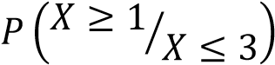

Solution
When x = 0, f(x) = ( ) =
When x = 2, f(x) = 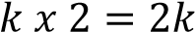

When x =
, f(x) =k (4
–

0
=
4)

2 4 x
0
f(x)

k
2

Area under the curve = 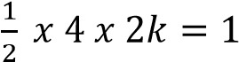
k =

(
b)(i
)

P(X< 1) =

∫
𝑥𝑑𝑥

=

0
𝑥

1

=

.

/

=

(
ii)
P(X >3) =

∫
(

𝑥
)
𝑑𝑥

=

0

𝑥

𝑥

1

=

0.125

(
iii)
P(1
≤

x
≤

3)=

∫
𝑥𝑑𝑥

∫

𝑥𝑘𝑑𝑥

=

0
𝑥

1

+

0

𝑥

𝑥

1

=

Example 39
A random variable X of a continuous p.d.f is given by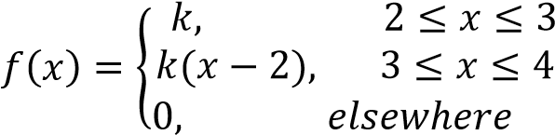

Find (i) the value of k and sketch the graph (ii) P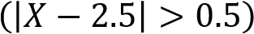 (iii) P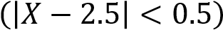
Area
under the curve = 1 x k +

(
𝑘

𝑘
)
𝑥

k =

ii) P
(
(
|
𝑋

|

)

=
P
(
-
0.5 <
X
-
2.5<0.5)

P(2 < X
<3)
=

=

∫
𝑑𝑥

,
𝑥
-

=

Solution
(i) When x = 2, f(x) =
When x = 3, f(x) = k

When x =
, f(x) =k (4
–

2)
= 2k

f(x)

k
2

k

3 4 x
2

f(x) = k

Finding p.d.f from a sketch graph of a continuous random variable
Example 40

C₃(3q)³
.⁵C₁1⁴( ) 